DAV HZL SR. SEC. SCHOOL, DARIBA
TENTATIVE CO-CURRICULAR ACTIVITIES 2022-23
Date | Classes | Events
15/04/23 | III TO V  VI TO VIII  IX TO XII | "Beaded Beauty: Exploring the Art of Beadwork"  Quelling Art: Exploring Paper Filigree Techniques"  "Preserving Our Planet: An Environmental Power Point Presentation"
29/04/23 | III TO V  VI TO IX | "Mastering English Eloquence"  "Quick Talk: English Extempore"
10/05/23 |  | Annual function
01/07/23 | III TO VII | Arya samaj related movie
07/07/23 | III TO VIII  IX TO XII | Trees are poems that the earth writes upon the sky.”Plantation drive  Inter-house documentary on exploring Dariba
15/07/23 | III TO V  VI TO IX | "Script Scribbles: The English Handwriting Challenge"  Hindi extempore
18/07/23 | III TO XII | "Crowning Moments: The Investiture Ceremony"
28/07/23 | III TO V  VI TO X | "Articulate Ambitions: The English Speech Contest" Inter-house  "Speak Up: The Power of Words"- English Debate Competition (Inter house English debate)
19/08/23 | III TO X | "Exploring Society: A Social Science Quiz"
02/09/23 | III TO V  VI TO X | Inter house Hindi speech  Inter house Hindi debate
07/10/23 | III TO V  VI TO VII  VIII  IX TO XII | Cartooning or Poster making Awareness towards Cleanliness  Rally  Community services  Inter house video making
21/10/23 | III TO V  VI TO VIII | Inter-house Singing bhajan With musical instrument  Shlok Manthan: Delving into the Depths of Sanskrit"
04/11/23 | III TO XII | "Sci-Quest: A Journey through the Wonders of Science"
18/11/23 |  | "Fun Fair Showcase" Exhibition and Fete
02/12/23 | III TO V  VI TO IX | "The Art of Expression: An English Monologue Competition"  "Act Out: An English Role play and Skit Competition"
23/12/23 | III TO XII | "Maths Mania Quiz"
06/01/24 | III TO V | "Mold Your Creativity" Clay Modelling
20/01/24 | III TO V | "Proudly Poetic: Celebrating Patriotism"  English Poem Recitation
27/01/24 | III TO V | "Folded Wonders- Origami Scenery Contest"
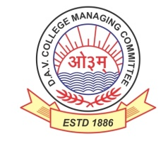
DAV HZL Sr. Sec. School dariba
rajsamand (raj.)

DAV HZL Sr. Sec. School dariba, rajsamand(raj.)

Split-up Syllabus
Class- III

Split-up Syllabus & Activities
for the session
2023-24
Class-III

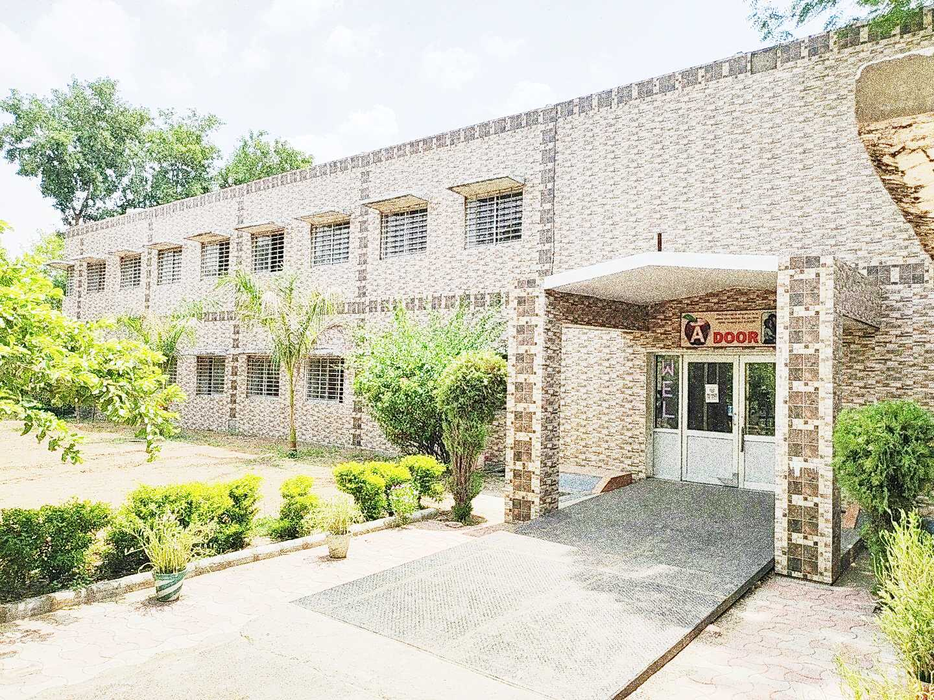

Address : Rajpura-Dariba, Distt. – Rajsamand (Raj.) 313211
Contact : (02952)265130 Email : davhzl_dariba@yahoo.com Website : www.davhzldariba.in
Subject | PT- I | PT- II
English | My Eng. Reader book - Unit - 1 Animal World  L. – I Speak, I Say ….  Practice Book - Nouns | My Eng. Reader book - :  2 – Dolphins  Practice Book - 2 Replacing Words
Hindi | Hkk"kk ek/kqjh ikB & 1] 2  Hkk"kk vH;kl ikB & 1] 2 | Hkk"kk ek/kqjh ikB & 3] 4  Hkk"kk vH;kl ikB & 3] 4
Maths | Ch. – 1 Numbers up to 9999 | Ch. – 2, 3
EVS/ Science | Chapter – 1 My Body | Ch. – 2, 3
S.St. | Chapter - 1 | Chapter – 2 & 3
Computer Sci. | Chapter – 1 | Chapter – 2, 3
Moral Edu. | ikB & 1] 2 | ikB & 3 ls 5
G. K. |  | Unit –I

Subject | Mid Term
English | My English Reader book – 3. Dogs 4. At the Zoo, 5. The Canary 6. The Ostriched, 7. The God of River  Practice Book - 3. Numbers, 4. Describing Words, 5. Verbs Compositions, Reading for understanding, Writing skills
Hindi | Hkk"kk ek/kqjh % ikB & 1 ls 8 rd  Hkk"kk vH;kl % ikB & 1 ls 8 rd
Maths | Chapter – 1 to 6
EVS/ Science | Chapter – 1 to Ch. – 5
S. St. | Chapter – 1 to 7
Computer Sc. | Chapter – 1 to 4
Moral Edu. | ikB & 1 ls 8
G. K. | Unit – I to III
Drawing | Page No. 2 to 20

Subject | PT- III
English | Reader Book – Lesson : 8. Trees are….. 9. Minu and 10. Trees  Practice Book –6. Preposition
Hindi | Hkk"kk ek/kqjh ikB & 11] 12 Hkk"kk vH;kl ikB & 11] 12
Maths | Chapter – 8, 9
EVS/ Science | Chapter – 6, 7
S.St. | Chapter – 8, 9
Computer Sc. | Chapter – 5 & 6
Moral Edu. | ikB & 9] 10
G. K. | Unit – IV

Subject | Final Term
English | Reader book – Unit-3 Regard for value Unit-4 Adventure  Practice Book – 7. Fixing words, 8. Sentences 9. Subject & Predicate 10. Composition  Reading for understanding, Writing skills
Hindi | Hkk"kk ek/kqjh ikB & 9 ls 16 Hkk"kk vH;kl ikB & 9 ls 16
Maths | Chapter – 7 to Ch. – 12
EVS/ Science | Chapter – 6, 7, 8, 9, 10
S. St. | Chapter – 8 to Chapter – 14
Computer Sc. | Chapter – 5 to 8
Moral Edu. | ikB & 9 ls 13 rd o vk;Z lekt ds fu;e
G. K. | Unit – IV to Unit – VI
Drawing | Page No. – 21 to 40

Exam | TENTATIVE DATES OF EXAM
PT – I | First week of May, 2023
PT- II | First week of August, 2023
MID – TERM | Mid September , 2023
PT – III | Last week of November, 2023
FINAL TERM | Third Week of February, 2024

