DAV HZL SR. SEC. SCHOOL, DARIBA
TENTATIVE CO-CURRICULAR ACTIVITIES 2022-23
Date | Classes | Events
15/04/23 | III TO V  VI TO VIII  IX TO XII | "Beaded Beauty: Exploring the Art of Beadwork"  Quelling Art: Exploring Paper Filigree Techniques"  "Preserving Our Planet: An Environmental Power Point Presentation"
29/04/23 | III TO V  VI TO IX | "Mastering English Eloquence"  "Quick Talk: English Extempore"
10/05/23 |  | Annual function
01/07/23 | III TO VII | Arya samaj related movie
07/07/23 | III TO VIII  IX TO XII | Trees are poems that the earth writes upon the sky.”Plantation drive  Inter-house documentary on exploring Dariba
15/07/23 | III TO V  VI TO IX | "Script Scribbles: The English Handwriting Challenge"  Hindi extempore
18/07/23 | III TO XII | "Crowning Moments: The Investiture Ceremony"
28/07/23 | III TO V  VI TO X | "Articulate Ambitions: The English Speech Contest" Inter-house  "Speak Up: The Power of Words"- English Debate Competition (Inter house English debate)
19/08/23 | III TO X | "Exploring Society: A Social Science Quiz"
02/09/23 | III TO V  VI TO X | Inter house Hindi speech  Inter house Hindi debate
07/10/23 | III TO V  VI TO VII  VIII  IX TO XII | Cartooning or Poster making Awareness towards Cleanliness  Rally  Community services  Inter house video making
21/10/23 | III TO V  VI TO VIII | Inter-house Singing bhajan With musical instrument  Shlok Manthan: Delving into the Depths of Sanskrit"
04/11/23 | III TO XII | "Sci-Quest: A Journey through the Wonders of Science"
18/11/23 |  | "Fun Fair Showcase" Exhibition and Fete
02/12/23 | III TO V  VI TO IX | "The Art of Expression: An English Monologue Competition"  "Act Out: An English Role play and Skit Competition"
23/12/23 | III TO XII | "Maths Mania Quiz"
06/01/24 | III TO V | "Mold Your Creativity" Clay Modelling
20/01/24 | III TO V | "Proudly Poetic: Celebrating Patriotism"  English Poem Recitation
27/01/24 | III TO V | "Folded Wonders- Origami Scenery Contest"
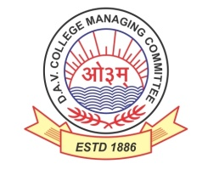
DAV HZL Sr. Sec. School dariba
rajsamand (raj.)

DAV HZL Sr. Sec. School dariba, rajsamand(raj.)

Split-up Syllabus
Class- III

Split-up Syllabus & Activities
for the session
2023-24
Class-IV

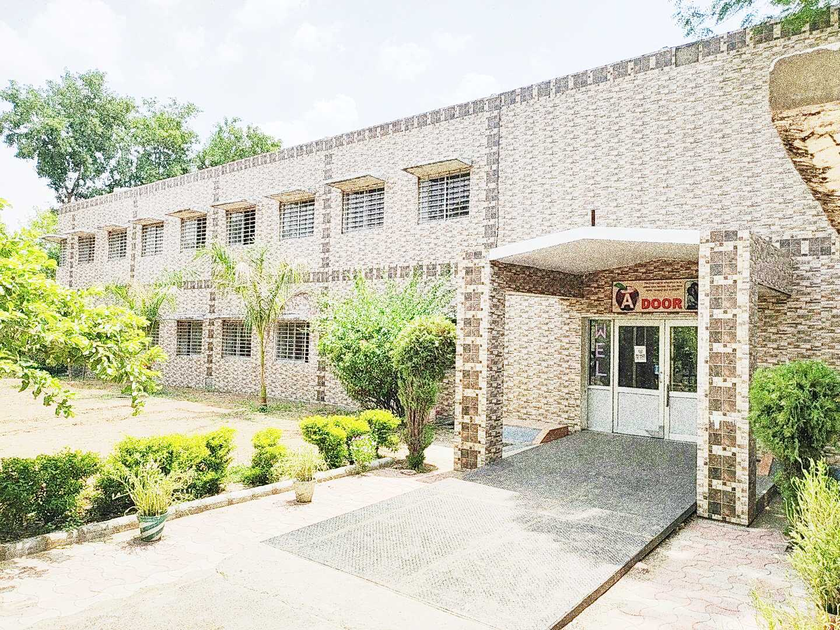

Address : Rajpura-Dariba, Distt. – Rajsamand (Raj.) 313211
Contact : (02952)265130 Email : davhzl_dariba@yahoo.com Website : www.davhzldariba.in
Subject | PT- I | PT- II
English | Reader Book - Unit - 1 Sports  L. – A True Friends  English Practice Book Ch. – 1 Naming words | Reader Book L. – 2 Mix up at Birth  English Practice Book Ch. – 2 Genders
Hindi | Hkk"kk ek/kqjh ikB & 1  Hkk"kk vH;kl ikB & 1 | Hkk"kk ek/kqjh ikB & 2  Hkk"kk vH;kl ikB & 2
Maths | Ch. – 1 | Ch. – 2 ,3
EVS/ Science | Chapter – 1 | Chapter – 2, 3
S.St. | Chapter - 1 | Chapter – 2 & 3
Computer Sci. | Chapter – 1 | Chapter – 2, 3
Moral Edu. | ikB & 1] 2 | ikB & 3 ls 5
G. K. |  | Unit – I

Subject | Mid Term
English | My English Reader – Unit – 1 Sports  Unit – 2 Travel  English Practice Book – Lesson – 1 to 5
Hindi | Hkk"kk ek/kqjh % ikB & 1 ls 9 rd  Hkk"kk vH;kl % ikB & 1 ls 9 rd  vifBr x|ka'k] dkWih esa djok;k x;k dk;Z
Maths | Chapter – 1, 2, 3, 4, 5, 6, 7
EVS/ Science | Chapter – 1 to 5
S. St. | Chapter – 1 to 7
Computer Sc. | Chapter – 1 to 4
Moral Edu. | ikB & 1 ls 10
G. K. | Unit – I to III
Drawing | Page No. 2 to 20

Subject | PT- III
English | Reader – Ch. – The Rich Lady and the Artist  Practice Book – Ch. 6 Determiners
Hindi | Hkk"kk ek/kqjh ikB & 10  Hkk"kk vH;kl ikB & 10
Maths | Chapter – 8, 9
EVS/ Science | Chapter – 6, 7
S.St. | Chapter – 8, 9
Computer Sc. | Chapter – 5 & 6
Moral Edu. | ikB & 11] 12] 13
G. K. | Unit – 4

Subject | Final Term
English | Reader – Unit – 3 Wit and Humour  Unit – 4 Fantasy  Practice Book – Lesson – 6 to 10
Hindi | Hkk"kk ek/kqjh ikB & 10 ls 18  Hkk"kk vH;kl ikB & 10 ls 18  vifBr x|ka'k] dkWih esa djok;k x;k dk;Z
Maths | Chapter – 8, 9, 10, 11, 12, 13, 14
EVS/ Science | Chapter – 6, 7, 8, 9, 10
S. St. | Chapter – 8 to Chapter – 13
Computer Sc. | Chapter – 5 to 8
Moral Edu. | ikB & 11 ls 21
G. K. | Unit – 4 to Unit - 6
Drawing | Page No. – 21 to 40

Exam | TENTATIVE DATES OF EXAM
PT – I | First week of May, 2023
PT- II | First week of August, 2023
MID – TERM | Mid September , 2023
PT – III | Last week of November, 2023
FINAL TERM | Third Week of February, 2024

