DAV HZL SR. SEC. SCHOOL, DARIBA
TENTATIVE CO-CURRICULAR ACTIVITIES 2022-23
Date | Classes | Events
15/04/23 | III TO V  VI TO VIII  IX TO XII | "Beaded Beauty: Exploring the Art of Beadwork"  Quelling Art: Exploring Paper Filigree Techniques"  "Preserving Our Planet: An Environmental Power Point Presentation"
29/04/23 | III TO V  VI TO IX | "Mastering English Eloquence"  "Quick Talk: English Extempore"
10/05/23 |  | Annual function
01/07/23 | III TO VII | Arya samaj related movie
07/07/23 | III TO VIII  IX TO XII | Trees are poems that the earth writes upon the sky.”Plantation drive  Inter-house documentary on exploring Dariba
15/07/23 | III TO V  VI TO IX | "Script Scribbles: The English Handwriting Challenge"  Hindi extempore
18/07/23 | III TO XII | "Crowning Moments: The Investiture Ceremony"
28/07/23 | III TO V  VI TO X | "Articulate Ambitions: The English Speech Contest" Inter-house  "Speak Up: The Power of Words"- English Debate Competition (Inter house English debate)
19/08/23 | III TO X | "Exploring Society: A Social Science Quiz"
02/09/23 | III TO V  VI TO X | Inter house Hindi speech  Inter house Hindi debate
07/10/23 | III TO V  VI TO VII  VIII  IX TO XII | Cartooning or Poster making Awareness towards Cleanliness  Rally  Community services  Inter house video making
21/10/23 | III TO V  VI TO VIII | Inter-house Singing bhajan With musical instrument  Shlok Manthan: Delving into the Depths of Sanskrit"
04/11/23 | III TO XII | "Sci-Quest: A Journey through the Wonders of Science"
18/11/23 |  | "Fun Fair Showcase" Exhibition and Fete
02/12/23 | III TO V  VI TO IX | "The Art of Expression: An English Monologue Competition"  "Act Out: An English Role play and Skit Competition"
23/12/23 | III TO XII | "Maths Mania Quiz"
06/01/24 | III TO V | "Mold Your Creativity" Clay Modelling
20/01/24 | III TO V | "Proudly Poetic: Celebrating Patriotism"  English Poem Recitation
27/01/24 | III TO V | "Folded Wonders- Origami Scenery Contest"
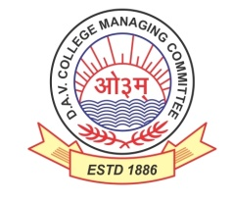
DAV HZL Sr. Sec. School dariba
rajsamand (raj.)

DAV HZL Sr. Sec. School dariba, rajsamand(raj.)

Split-up Syllabus
Class- III

Split-up Syllabus & Activities
for the session
2023-24
Class-VI

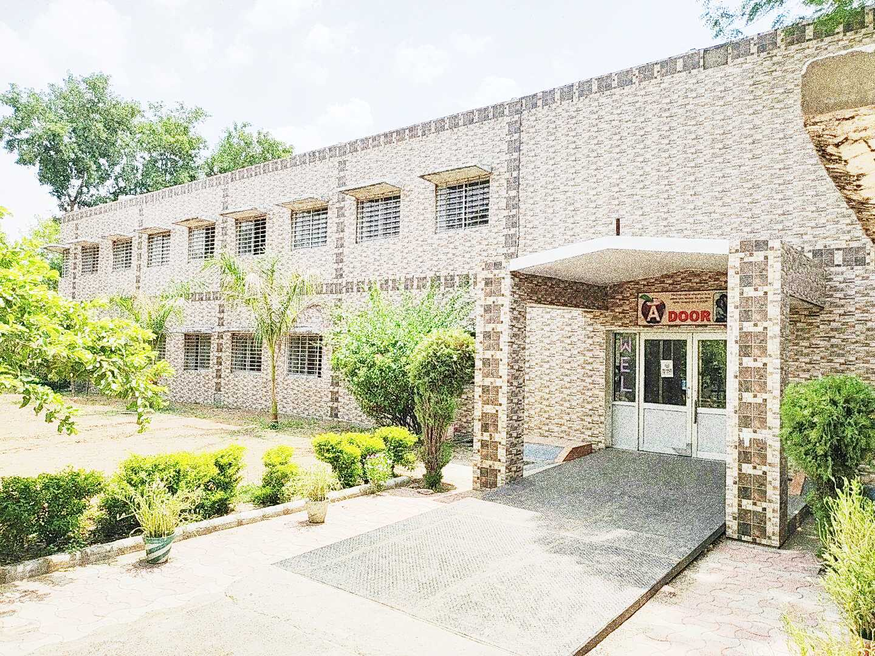

Address : Rajpura-Dariba, Distt. – Rajsamand (Raj.) 313211
Contact : (02952)265130 Email : davhzl_dariba@yahoo.com Website : www.davhzldariba.in
Subject | PT- I | PT- II
English | Eng. Lit. – Lesson – 1  Practice Book – Lesson – 1 | Eng. Lit. – Lesson – 2  Practice Book – Lesson – 2
Hindi | Kku lkxj % ikB & 1  vH;kl lkxj % ikB & 1 | Kku lkxj % ikB & 2  vH;kl lkxj % ikB & 2
Maths | Lesson – 1 Natural numbers & Whole numbers | Lesson – 2 Factors & Multiplies
Science | Lesson – 1 | Lesson – 2
S.St. | Lesson – 1, 8 | Chapter – 9, 21
laLÑr | ikB & 1 o laLÑr o.kZekyk | ikB & 2] 3 rFkk loZuke 'kCn:i ¼f="kq fya³xs"kq½
Computer Sc. | Chapter – 1 | Chapter – 2
Moral Edu. | ikB & 1] 2 | ikB & 3
G. K. |  | Unit – 5

Subject | Mid Term
English | Eng. Lit. – Lesson – 1 to 5  Practice Book – Lesson – 1 to 5  Reader Book – Unit 1 to 3
Hindi | Kku lkxj % ikB & 1] 2] 3] 4] 6] 7] 8  vH;kl lkxj % ikB & 1] 2] 3] 4] 5] 6] 7] 8  vifBr x|ka'k] vifBr dkO;ka'k
Maths | Lesson – 1 to 6, 8 & 9
Science | Lesson – 1, 2, 3, 4, 5, 6 and 7
S. St. | Lesson – 1, 2, 3, 4, 8, 9, 10, 11, 12, 13, 21, 22, 23
laLÑr | ikB & 1 ls 6 laLÑr o.kZekyk] 'kCn:i ¼loZuke o ckyd] Qy] yrk½] /kkrq:i yV~ydkj o y³~ydkj] dkjdL; ifjp;% ¼izFkek ls r`rh;k½ vifBr x|ka'ke~] fp=o.kZue~] i= ys[kue~] okD;kuqokn
Computer Sc. | Chapter – 1 to 4
Moral Edu. | ikB & 1 ls 10
G. K. | Unit – 4 to 6
Drawing | Page No. 2 to 20
Subject | PT- III
English | Eng. Lit. – Lesson – 6 Practice Book – Lesson – 6
Hindi | Kku lkxj % ikB & 9 vH;kl lkxj % ikB & 9
Maths | Lesson – 7
Science | Lesson – 8 & 9
S.St. | Chapter – 5, 14, 15
laLÑr | ikB & 7] 8 rFkk vO;;] milxZ
Computer Sc. | Chapter – 5 & 6
Moral Edu. | ikB & 11 ls 12
G. K. | Unit – 2

Subject | Final Term
English | Eng. Lit. – Lesson – 6 to 11  Practice Book – Lesson – 6 to 10  Reader Book – Unit – 4 to 6
Hindi | Kku lkxj % ikB & 9] 10] 12] 13] 14] 15] 17] 18] 20  vH;kl lkxj % ikB & 9] 10] 11] 12] 13] 14] 15] 16] 17] 18] 19] 20  vifBr x|ka'k] vifBr dkO;ka'k
Maths | Lesson – 7, 10 to 16
Science | Lesson – 8, 9, 10, 11, 12, 13 and 14
S.St. | History: - Chapter – 14, 15, 16, 17, 18, 19, 20  Geography :- Chapter - 5, 6, 7  Civics :- Chapter – 24
laLÑr | ikB & 7 ls 11] laLÑr o.kZekyk] 'kCn:i ¼eqfu] lk/kq] efr½ y`V~ydkj /kkrq:i] milxZ] vO;;] dkjd ¼prqFkhZ ls lIreh½ vifBr x|ka'ke~ fp=o.kZue~] i= ys[kue~] okD;kuqokn
Comp. Sc. | Chapter – 5 to 8
Moral Edu. | ikB & 11 ls 20
G. K. | Unit - 1 to 3
Drawing | Page No. – 21 to 40

Exam | TENTATIVE DATES OF EXAM
PT – I | First week of May, 2023
PT- II | First week of August, 2023
MID – TERM | Mid September , 2023
PT – III | Last week of November, 2023
FINAL TERM | Third Week of February, 2024

