DAV HZL SR. SEC. SCHOOL, DARIBA
TENTATIVE CO-CURRICULAR ACTIVITIES 2022-23
Date | Classes | Events
15/04/23 | III TO V  VI TO VIII  IX TO XII | "Beaded Beauty: Exploring the Art of Beadwork"  Quelling Art: Exploring Paper Filigree Techniques"  "Preserving Our Planet: An Environmental Power Point Presentation"
29/04/23 | III TO V  VI TO IX | "Mastering English Eloquence"  "Quick Talk: English Extempore"
10/05/23 |  | Annual function
01/07/23 | III TO VII | Arya samaj related movie
07/07/23 | III TO VIII  IX TO XII | Trees are poems that the earth writes upon the sky.”Plantation drive  Inter-house documentary on exploring Dariba
15/07/23 | III TO V  VI TO IX | "Script Scribbles: The English Handwriting Challenge"  Hindi extempore
18/07/23 | III TO XII | "Crowning Moments: The Investiture Ceremony"
28/07/23 | III TO V  VI TO X | "Articulate Ambitions: The English Speech Contest" Inter-house  "Speak Up: The Power of Words"- English Debate Competition (Inter house English debate)
19/08/23 | III TO X | "Exploring Society: A Social Science Quiz"
02/09/23 | III TO V  VI TO X | Inter house Hindi speech  Inter house Hindi debate
07/10/23 | III TO V  VI TO VII  VIII  IX TO XII | Cartooning or Poster making Awareness towards Cleanliness  Rally  Community services  Inter house video making
21/10/23 | III TO V  VI TO VIII | Inter-house Singing bhajan With musical instrument  Shlok Manthan: Delving into the Depths of Sanskrit"
04/11/23 | III TO XII | "Sci-Quest: A Journey through the Wonders of Science"
18/11/23 |  | "Fun Fair Showcase" Exhibition and Fete
02/12/23 | III TO V  VI TO IX | "The Art of Expression: An English Monologue Competition"  "Act Out: An English Role play and Skit Competition"
23/12/23 | III TO XII | "Maths Mania Quiz"
06/01/24 | III TO V | "Mold Your Creativity" Clay Modelling
20/01/24 | III TO V | "Proudly Poetic: Celebrating Patriotism"  English Poem Recitation
27/01/24 | III TO V | "Folded Wonders- Origami Scenery Contest"
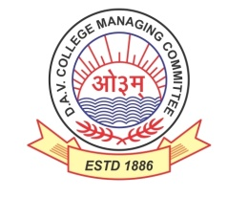
DAV HZL Sr. Sec. School dariba
rajsamand (raj.)

DAV HZL Sr. Sec. School dariba, rajsamand(raj.)

Split-up Syllabus
Class- III

Split-up Syllabus & Activities
for the session
2023-24
Class-VII

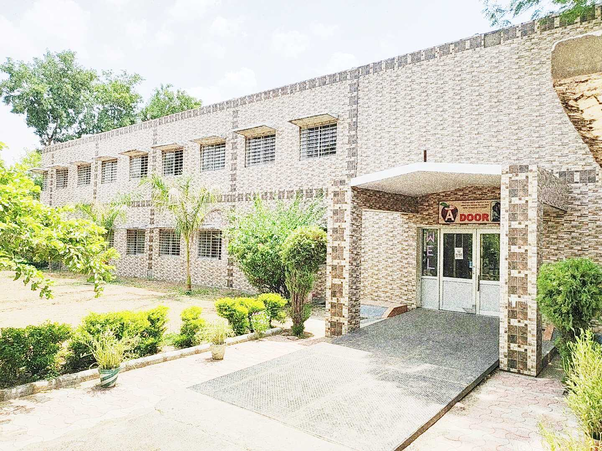

Address : Rajpura-Dariba, Distt. – Rajsamand (Raj.) 313211
Contact : (02952)265130 Email : davhzl_dariba@yahoo.com Website : www.davhzldariba.in
Subject | PT- I | PT- II
English | Eng. Lit. – Lesson – 1  Practice Book – Lesson – 1 | Eng. Lit. – Lesson – 3  Practice Book – Lesson – 2
Hindi | Kku lkxj % ikB & 1  vH;kl lkxj % ikB & 1 | Kku lkxj % ikB & 2  vH;kl lkxj % ikB & 2
Maths | L. –2 Operations on Rational Numbers | L. – 1 Rational Numbers
Science | L. – 1 | L. – 2
S.St. | L. – 1, 2 | Chapter – 9, 18, 19
laLÑr | ikB & 1 o /kkrq:ik.kka iz;ksx% | ikB & 2] 3
Computer Sc. | Chapter – 1 | Chapter – 2
Moral Edu. | ikB & 1 | ikB & 2
G. K. |  | Unit – 5

Subject | Mid Term
English | Eng. Lit. – Lesson – 1 to 5 Practice Book – Lesson – 1 to 5  Reader Book – Unit 1 to 3
Hindi | Kku lkxj % ikB & 1 ls 10  vH;kl lkxj % ikB & 1 ls 10 vifBr x|ka'k
Maths | L. – 1 to 7
Science | L. – 1, 2, 3, 4, 5, 6, 7, 8
S. St. | Chapter – 1, 2, 3, 4, 9, 10, 11, 12, 18, 19, 20 & 21
laLÑr | ikB & 1 ls 5 O;kdj.ke~ & /kkrq:i] 'kCn:i] milxZ&vO;;] izR;;%] lfU/k miin foHkfDr] vifBr x|ka'ke~] fp=o.kZue~] i=ys[kue~] vuqPNsn ys[kue~] okD;kuqokn
Computer Sc. | Chapter – 1 to 4
Moral Edu. | ikB & 1 ls 10
G. K. | Unit – 4 to 6
Drawing | Page No. 2 to 20

Subject | PT- III
English | Eng. Lit. – Lesson – 7 Practice Book – Lesson – 7
Hindi | Kku lkxj % ikB & 11 vH;kl lkxj % ikB & 11
Maths | Lesson – 8 & 9
Science | Lesson – 9, 10
S.St. | Chapter – 5, 6 & 13
laLÑr | ikB & 6] 7 fo'ks"k.k&fo'ks";
Computer Sc. | Chapter – 5 & 6
Moral Edu. | ikB & 11
G. K. | Unit – 2

Subject | Final Term
English | Eng. Lit. – Lesson – 6 to 11  Practice Book – Lesson – 6 to 11  Reader Book – Unit – 4 to 6
Hindi | Kku lkxj % ikB & 11 ls 20 rd  vH;kl lkxj % ikB & 11 ls 20 rd  vifBr x|ka'k] vifBr dkO;ka'k
Maths | Lesson – 8 to 14
Science | Lesson – 9, 10, 11, 12, 13, 14, 15, 16, 17
S.St. | Chapter – 5, 6, 7, 8, 13, 14, 15, 16, 17, 22, 23
laLÑr | ikB & 6 ls 10 O;kdj.k & fo'ks"k.k&fo'ks";] loZuke 'kCn:i] milxZ& vO;;] izR;;] laf/k] la[;k ¼1&50½ miin foHkfDr ¼prqFkhZ ls lIreh½] fp=o.kZue~] i=ys[kue~] vuqPNsn ys[kue~] okD;kuqokn
Computer Sc. | Chapter – 5 to 8
Moral Edu. | ikB & 11 ls 20] vk;Z lekt ds fu;e
G. K. | Unit - 1 to 3
Drawing | Page No. – 21 to 47

Exam | TENTATIVE DATES OF EXAM
PT – I | First week of May, 2023
PT- II | First week of August, 2023
MID – TERM | Mid September , 2023
PT – III | Last week of November, 2023
FINAL TERM | Third Week of February, 2024

