DAV HZL SR. SEC. SCHOOL, DARIBA
TENTATIVE CO-CURRICULAR ACTIVITIES 2022-23
Date | Classes | Events
15/04/23 | III TO V  VI TO VIII  IX TO XII | "Beaded Beauty: Exploring the Art of Beadwork"  Quelling Art: Exploring Paper Filigree Techniques"  "Preserving Our Planet: An Environmental Power Point Presentation"
29/04/23 | III TO V  VI TO IX | "Mastering English Eloquence"  "Quick Talk: English Extempore"
10/05/23 |  | Annual function
01/07/23 | III TO VII | Arya samaj related movie
07/07/23 | III TO VIII  IX TO XII | Trees are poems that the earth writes upon the sky.”Plantation drive  Inter-house documentary on exploring Dariba
15/07/23 | III TO V  VI TO IX | "Script Scribbles: The English Handwriting Challenge"  Hindi extempore
18/07/23 | III TO XII | "Crowning Moments: The Investiture Ceremony"
28/07/23 | III TO V  VI TO X | "Articulate Ambitions: The English Speech Contest" Inter-house  "Speak Up: The Power of Words"- English Debate Competition (Inter house English debate)
19/08/23 | III TO X | "Exploring Society: A Social Science Quiz"
02/09/23 | III TO V  VI TO X | Inter house Hindi speech  Inter house Hindi debate
07/10/23 | III TO V  VI TO VII  VIII  IX TO XII | Cartooning or Poster making Awareness towards Cleanliness  Rally  Community services  Inter house video making
21/10/23 | III TO V  VI TO VIII | Inter-house Singing bhajan With musical instrument  Shlok Manthan: Delving into the Depths of Sanskrit"
04/11/23 | III TO XII | "Sci-Quest: A Journey through the Wonders of Science"
18/11/23 |  | "Fun Fair Showcase" Exhibition and Fete
02/12/23 | III TO V  VI TO IX | "The Art of Expression: An English Monologue Competition"  "Act Out: An English Role play and Skit Competition"
23/12/23 | III TO XII | "Maths Mania Quiz"
06/01/24 | III TO V | "Mold Your Creativity" Clay Modelling
20/01/24 | III TO V | "Proudly Poetic: Celebrating Patriotism"  English Poem Recitation
27/01/24 | III TO V | "Folded Wonders- Origami Scenery Contest"
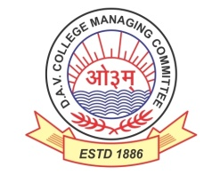
DAV HZL Sr. Sec. School dariba
rajsamand (raj.)

DAV HZL Sr. Sec. School dariba, rajsamand(raj.)

Split-up Syllabus
Class- III

Split-up Syllabus & Activities
for the session
2023-24
Class-XI (Comm.)

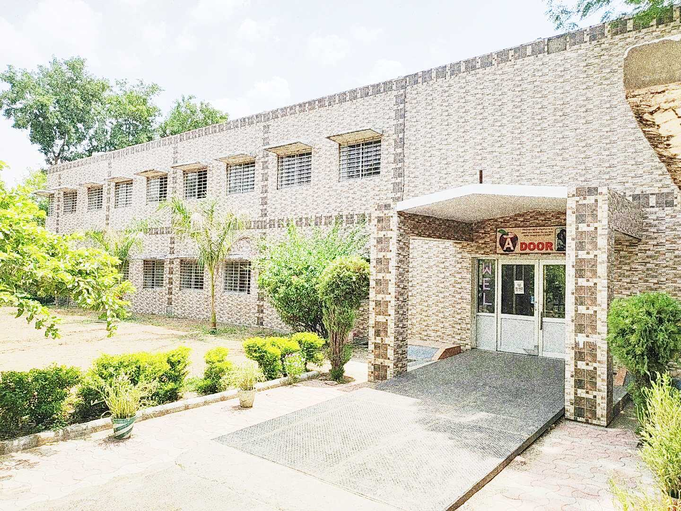

Address : Rajpura-Dariba, Distt. – Rajsamand (Raj.) 313211
Contact : (02952)265130 Email : davhzl_dariba@yahoo.com Website : www.davhzldariba.in
Subject | UT- I | UT – II
English | The Portrait of lady  A Photograph  Note Making / summary | We are not afraid to Die, Laburnum Top, Tenses, Transformation of Sentences, Classifieds
Accountancy | Ch. – 1 to 2 | Ch. – 3, 4, 5
Economics | Ch. – 1 to 3 | Micro Economics  Unit – Demand
Business St. | Ch. – 1 to 2 | Ch. 2 to 4
Physical Education | Unit – I & II | Unit – III & IV

Subject | Mid Term
English | We are not afraid to die, The Address, Discovering Tut, The Laburnum Top, The Summers of Beautiful White Horse, Tenses Transformation of sentences / Classifieds
Accountancy | Ch. – 1 to 8
Economics | Ch. – 1 to 5 Micro Economics, Mean, Median and Mode
Business St. | Ch. – 1 to 7
Physical Education | Unit - 1, 2, 3, 4, 5

Subject | UT – III
English | Silk Road, Father to Son, Mother’s Day, Birth, Poster, Speech writing
Accountancy | Ch. – 9 to 10
Economics | Mean Deviation, Quartile, Standard deviation
Business St. | Ch. –8 to 10
Physical Education | Unit – 6, 7

Subject | Final Term
English | Complete course as per CBSE Board
Accountancy | Complete course as per CBSE Board
Economics | Complete course as per CBSE Board
Business St. | Complete course as per CBSE Board
Physical Education | Complete course as per CBSE Board

Exam | TENTATIVE DATES OF EXAM
UT- I | First week of May , 2023
UT- II | First week of August, 2023
MID – TERM | Mid September , 2023
UT – III | Last Week of November, 2023
Pre Board – I | 2nd- 3rd week of December
Pre Board – II | Third Week of January, 2024
Final Term | Third Week of February, 2024

