DAV HZL SR. SEC. SCHOOL, DARIBA
TENTATIVE CO-CURRICULAR ACTIVITIES 2022-23
Date | Classes | Events
15/04/23 | III TO V  VI TO VIII  IX TO XII | "Beaded Beauty: Exploring the Art of Beadwork"  Quelling Art: Exploring Paper Filigree Techniques"  "Preserving Our Planet: An Environmental Power Point Presentation"
29/04/23 | III TO V  VI TO IX | "Mastering English Eloquence"  "Quick Talk: English Extempore"
10/05/23 |  | Annual function
01/07/23 | III TO VII | Arya samaj related movie
07/07/23 | III TO VIII  IX TO XII | Trees are poems that the earth writes upon the sky.”Plantation drive  Inter-house documentary on exploring Dariba
15/07/23 | III TO V  VI TO IX | "Script Scribbles: The English Handwriting Challenge"  Hindi extempore
18/07/23 | III TO XII | "Crowning Moments: The Investiture Ceremony"
28/07/23 | III TO V  VI TO X | "Articulate Ambitions: The English Speech Contest" Inter-house  "Speak Up: The Power of Words"- English Debate Competition (Inter house English debate)
19/08/23 | III TO X | "Exploring Society: A Social Science Quiz"
02/09/23 | III TO V  VI TO X | Inter house Hindi speech  Inter house Hindi debate
07/10/23 | III TO V  VI TO VII  VIII  IX TO XII | Cartooning or Poster making Awareness towards Cleanliness  Rally  Community services  Inter house video making
21/10/23 | III TO V  VI TO VIII | Inter-house Singing bhajan With musical instrument  Shlok Manthan: Delving into the Depths of Sanskrit"
04/11/23 | III TO XII | "Sci-Quest: A Journey through the Wonders of Science"
18/11/23 |  | "Fun Fair Showcase" Exhibition and Fete
02/12/23 | III TO V  VI TO IX | "The Art of Expression: An English Monologue Competition"  "Act Out: An English Role play and Skit Competition"
23/12/23 | III TO XII | "Maths Mania Quiz"
06/01/24 | III TO V | "Mold Your Creativity" Clay Modelling
20/01/24 | III TO V | "Proudly Poetic: Celebrating Patriotism"  English Poem Recitation
27/01/24 | III TO V | "Folded Wonders- Origami Scenery Contest"
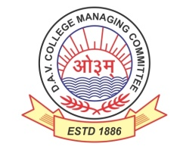
DAV HZL Sr. Sec. School dariba
rajsamand (raj.)

DAV HZL Sr. Sec. School dariba, rajsamand(raj.)

Split-up Syllabus
Class- III

Split-up Syllabus & Activities
for the session
2023-24
Class-XII (Comm.)

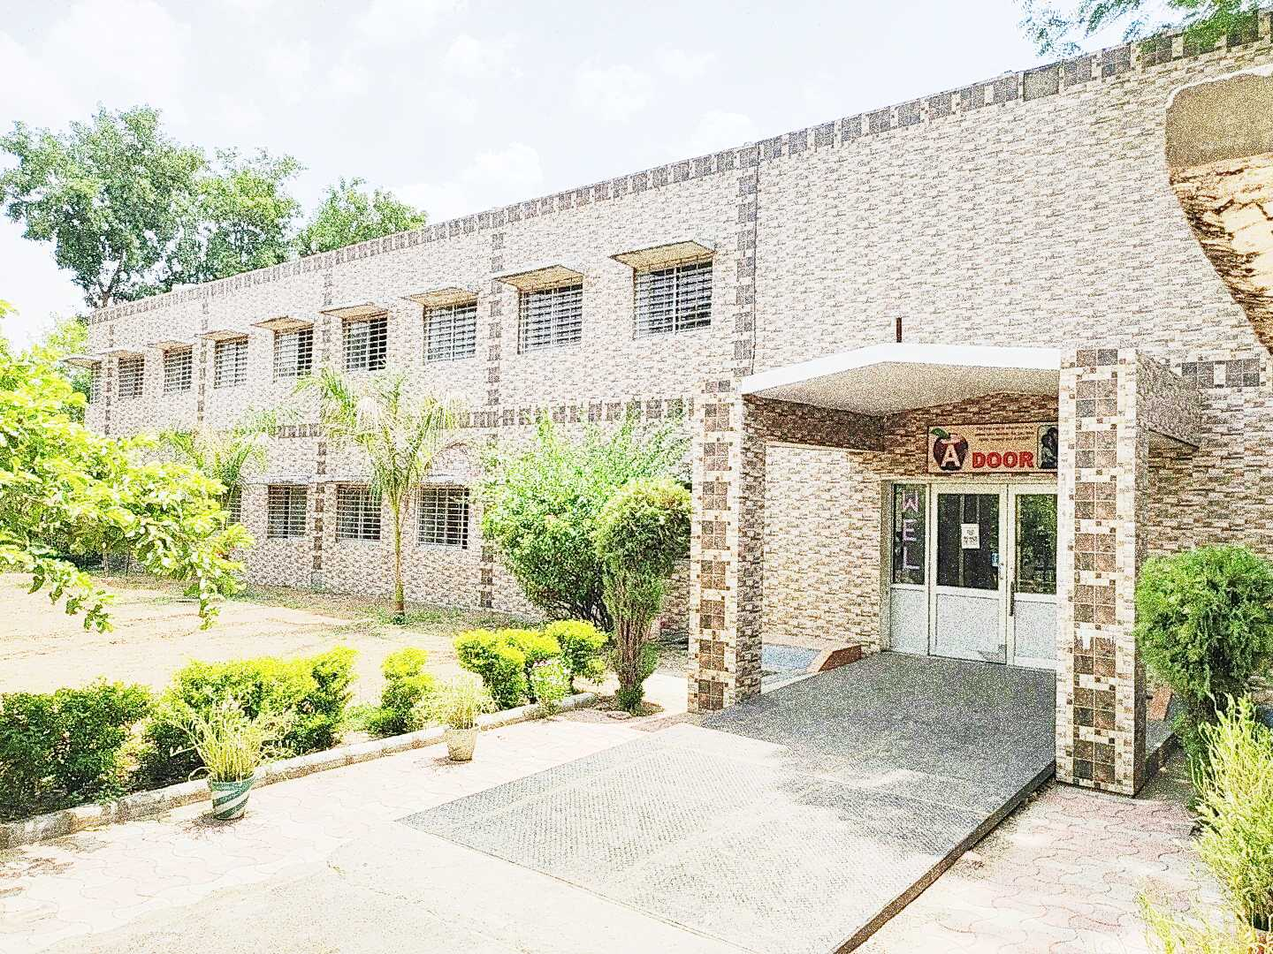

Address : Rajpura-Dariba, Distt. – Rajsamand (Raj.) 313211
Contact : (02952)265130 Email : davhzl_dariba@yahoo.com Website : www.davhzldariba.in
Subject | UT- I | UT- II
English | The Last Lesson, My Mother at Sixty Six, Notice Writing | Lost Spring ,Deep Water, Keeping Quiet ,A Thing of Beauty, The Third Level, The Tiger King, Formal/Informal Invitation and Reply
Accountancy | Ch. – 1 | Ch. – 1 to 3
Economics | Unit – I National Income | Unit- 3 & 4 Macro Economics
Business St. | Ch. – 1 to 2 | Ch. – 3, 4, 5
Physical Education | Unit – I & II | Unit – III & IV

 | Subject | Mid Term
 | English | The Last Lesson, Lost Spring, Deep Water, The Rattrap, My Mother at Sixty-Six, Keeping Quiet, A Thing of Beauty, The Third Level, The Tiger King, Journey to the end of the Earth, The Enemy, Notice Writing, Formal/Informal Invitation and Reply, Letter Writing
 | Accountancy | Unit - I & II
 | Economics | Macro Economics Complete
 | Business St. | Ch. – 1 to 7
 | Physical Education | Unit – I to VI
Subject |  | UT - III
English |  | Indigo, Poets and Pancakes, A Roadside Stand, On the Face of It, Memories of Childhood, Article/ Report Writing
Accountancy |  | Unit I, II & III
Economics |  | Unit – 1 Indian Economy
Business St. |  | Ch. –8 to 10
Physical Education |  | Unit – VII & VIII

Subject | Pre Board and Final Term syllabus as per CBSE
English | Complete course as per CBSE Board
Accountancy | Complete course as per CBSE Board
Economics | Complete course as per CBSE Board
Business St. | Complete course as per CBSE Board
Physical Education | Complete course as per CBSE Board

Exam | TENTATIVE DATES OF EXAM
UT- I | First week of May , 2023
UT- II | First week of August, 2023
MID – TERM | Mid September , 2023
UT – III | Last Week of November, 2023
Pre Board – I | 2nd- 3rd week of December
Pre Board – II | Third Week of January, 2024
Final Term | Third Week of February, 2024

