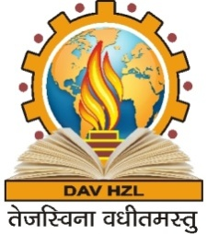
DAV HZL SENIOR SECONDARY SCHOOL
RAJPURA-DARIBA, RAJSAMAND (RAJ.) 313211
C.B.S.E. Affiliation No. 1730592
(Managed By: DAV College Managing Committee, New Delhi)
Session 2015-16
Schedule for Summative Assessment –II

Date | I | II | III | IV | V | VI | VII
27.02.16 | ENGLISH | MATHS | S.ST | SCIENCE | MATHS | ENGLISH | ENGLISH
29.02.16 | EVS | EVS | SCIENCE | MATHS | S.ST | HINDI | SCIENCE
02.03.16 | COMP./DRAW | HINDI | COMP./ DRAW | S.ST | HINDI | MATHS | HINDI
04.03.16 | MATHS | COMP./ DRAW | ENGLISH | COMP./DRAW | COMP./ DRAW | COMP/ DRAW | COMP/ DRAW
07.03.16 | HINDI | ENGLISH | MATHS | ENGLISH | ENGLISH | S.ST | MATHS
09.03.16 | OFF | OFF | HINDI | HINDI | SANSKRIT | SANSKRIT | S.ST.
11.03.16 | OFF | OFF | OFF | OFF | SCIENCE | SCIENCE | SANSKRIT

Note-
1. Oral and written examinations of a subject will be conducted on the same dates. (Class I to V)
2. Preparatory leave will be on 26.02.16 for class I to VII.
3. School timing during the examination days will be from 8.45 a.m. to 12.00 noon.
4. There will be no teaching during examination days.
5. Result of the examination will be declared on 22/03/2016 at 9:00 a.m.
6. New Session (2016-17) to commence from 06.04.2016 (Wednesday)

(D.Sen Sharma)
Principal

