CLASS-VI
Chpter-1.
Natural Numbers and whole numbers
- Roman numerals
- Number line
- Successor and predecessor
- All operation of whole number
- Distributive property
- Solve by rearranging
- ROMAN NUMERALS
Hindu Arabic Roman
1 I
2 II
3 III
4 IV
5 V
6 VI
7 VII
8 VIII
9 IX
10 X
20 XX
30 XXX
40 XL
50 L
60 LX
70 LXX
80 LXXX
90 XC
100 C
110 CX
500 D
1000 M

Q. Convert into Roman numerals.
(a) 19 (b) 78
19 =10+9= X IX 78=70+8=50+10+10+8= L X X VIII
C.W:- (a) 58 (b) 91

Q. Convert into Hindu Arabic Numerals.
(a) XXVI = X X VI = 10+10+6 =26
(b) XLl = XL l = 40+1 = 41
C.W. – (a) XCVII (b) LXXXV
H.W. - (a) XXIX (b) XLV
Solve and write the result in Roman.
- 12x7 = 84 = 50+10+10+10+4 = LXXXIV
- 216-174 = 42 = 40+2 = XLII
C.W. (a) 32+67 (b) 296-198
H.W. (a) 3645 ÷ 45 (b) 121 ÷ 11

Fill in the blanks .using roman numerals

CXIX - ------------------ = XXV
100 +10+9 - __________ = 10+10+5
119-25 =94
Number is 94
119 -94 =25
94 = 90 +4 = XCIV
CXIX – XCIV = XXV

C.W. - ________ +XLVI = LXX.
H.W. – LXX +________ =XCV

Q. Arrange the following in ascending order
(a) LVII ,XC ,XV ,LXIV , LXXI
(b) XX ,XIV ,VI ,XL , IX

Q. Which is meaningless.
(a) XLI (c) IV C
(b) IC (d) LIL

Q. Write in roman numerals
(a) year in which india become republic.
(b) In which years india won the world cup ?

- NUMBER LINE

(a) Naturals number :- Numbers start from 1 (1,2,3,….)
(b) Whole number – Number start From 0 (0,1,2,3…..)

….-4 -3 -2 -1 0 1 2 3 4 …….
Naturals numbers

Whole numbers
Q. the smallet +ve number 1
Q. The greatest + ve number not define
Q. The smallest –ve number not define
Q. the greater –ve number -1
Q. The smallest whole number . 0
(3) Successor and predecessor

Predecessor(always left) Successor(always right)

Q. Success of -

a) -3 (b) 16 (c) -11 (d) 196

(a) -2 (b) 17 (c) -10 (d) -197

Q. predecessor of -

(a) -100 (b) 15 (c) 103 (d) -7
(a) -101 (b) 14 (c) 102 (d) -8

Write successor and predecessor of
(a) -1001 (b) 50001 (c) -1

One digit numbers 0 -9
Two digit numbers 10-99
Three digit numbers 100-999
Four digit numbers 1000-9999
Five digit numbers 10000-99999
Six digit numbers 100000 – 999999

Q. How to find out the smallest and the greater digits number from given digits

Q. Form the greatest -7 digits number from 3,8,9.
9 9 9 9 9 8 3

Use the smallest number at unit and next greater number at 10 th plane after all are the greatest number.

C.W. Form the greatest 9 digit number from 7,6,5.

H.W. From the greatest 6 digit number from 1,7,4.

Q. Form smallest 6 digits number from 4 ,5,0 and 6,1,7.
4 0 0 0 0 5
1 1 1 1 6 7
The greatest number unit plane

C.W.- Form the smallest 8 digit number from 7 ,0 ,4.

H.W. - Form the smallest 7 digits number from 5 ,1,7.

Important points :
(a) 5 x 0 = 0
(b) 8$÷$1 = 8
(c) 5 $÷$5 = 1
(d) 5 +0 = 5
(e) 5-0 = 5
H.W.
9 x1 =……… 4+0= ………
7$÷$ 1=……… 4-0 =……….
4 $÷$ 4 = …….. 4x0 =……….

(4) Distributive property :

ax(b+c)=axb+axc
ax (b-c) = axb –axc

Q. 52 x (63+37) = 52x63 + 52x37

Q. 76 x (91-18) = 76 x91 – 76 x18

Q. (i) 241 x 107 (ii) 999 x 399
241x(100+7) 399x(1000-1)
241x100+241x7 399000-399
24100+1687 398601
25787
Q. (iii) 85 x15 +15 +x15 (iv) 638x201-638
85x15+15x15 638x201-638x1
15x(85+15) 638x(201-1)
15x100 638x200
1500 127600
C.W. (i) 1009x1392
(ii) 750 x17 +750x38 +27 x750 +18
H.W.
(i) 688x10x437-6880x337
(ii) 98x553
(iii) 788x10x438 – 7880 x 437
(iv) 223x25x6 – 223x10x15

(5) Rearrange and Solve :

(a) 125x8x488
125x8x488
1000x488
488000

(b) 200x625x16x50
200x50x625x16
10000x10000
100000000
Important Tips :
25 x4=100
50x2=100
125x8=1000
16x625=10000
25x40=1000

C.W. – (a) 200x1975x5
(b) 16x125x8x625

H.W. – (a) 725x25x10x4
(b) 916x125x10x8

(a) 786 +342+ 214
786+342+214
1000+342
1342

(b) 20650+547+938+353
2062+938+547+353
3000+900
= 3900

(c) 1015 +2011-115-211
1015-115+2011-211
900+1800
2700
Convert into nearest hundred .and ten thousand etc.
C.w. - (A) 637+908+363
(B) 479+2000+21
H.W. – (A) 1637+1908+363
(B) 786+341-286-141
Q. Find the least number that should be added to 2000 so that 45 devides the sum exactly.
45)2000(44
180
200
180
20
45-20=25
2000+25=2025

(C.W.) Q. Find the least number should be added to 5000 so that 35 devides the sum exactly .
(H.W.) Q. Find the least number should be added to 7000 so that 55 divides the sum exactly.
Q. Find the largest 5 digits number which is exactly divisible by 40.
40)99999(2499
80
199
160
399
360
399
360
39

99999-39=99960

Q. find the largest 6 digits number which is exactly divisible by 50.

Q. Find the largest 4 digits number which is exactly divisible by 40.

CHAPTER-2
FACTORS AND MULTIPLES
In this Lesson:-
1. Multiples 5. Test of Divisibility
2. Factors 6. Prime Factorization
3. Prime numbers 7. H.C.F
4. Composite numbers 8. L.C.M

- Multiples:- Multiplication table of that number
Ex. Multiples of 4 is - 4, 8, 12, .……………………..(table of 4)
Multiples of 7 is - 7, 14, 21, ………………………….(table of 7)

- Factors: - A factor of a number divides the number exactly.
Ex. Factors of 12 is ------- 1, 2, 3, 4, 5, 6, and 12.
12 - 1X12 12 - 4X3
12 - 2X6 12 - 6X2
- -3X4 12 - 12X1

Prime number: - A number which has only two factors 1 and itself.
23 - 1X23, 23X1 (23 has two factors 1 and itself 23)
25 - 1X25, 5X5, 25X1 (25 has 3 factors 1, 5, and 25)

Twin Prime:- Two Prime numbers whose difference is 2 are called twin Prime.
Ex:- 3, 5 is a twin Prime because 5-3=2(difference is 2)
5, 7 is a twin Prime because 7-5=2(difference is 2)
Q. Which is twin Prime 41, 43, or 53, 59
Ans. 41, 43 is a twin Prim because 43-41=2 9difference is 2)
53, 59 is not a twin Prime because 59-53=6(difference is not 2)
C.W – Q:- which is twin Prime 59, 61 or 79, 83.
Co-Prime:- Two numbers having no common factor except 1 are called Co-Prime number.

Ex:- 3, 5 19, 20
3 - 1X3 19 - 1X19
5 - 1X5 20 - 1X20, 2X10, 4X5, 5X4, 10X2, 20X1
Only One Common factor 1
Q. Which is Co-Prime 5, 11, or 20, 24
Ans. 5, 11 20,24
5 - 1X5 20 - 1X20, 2X10, 4X5, 5x4, 10X2, 20X1
11 - 1X11 24 - 1X24, 2X12, 3X8, 4X6, 6X4, 8X3, 12X2, 24X1
Sum of two odd Primes:- 18 - 5+13, 7+11 32 - 3+29, 13+19
Sum of three odd Primes:- 41 - 5+7+29, 7+11+23

Composite number: - A number which has more than 2 factors is called Composite numbers.(Numbers which is not Prime they are all composite).
Important
1 - neither Prime nor composite
2 - The smallest even Prime number (1x2, 2x1 only Prime even number)
3 - The smallest odd Prime number (1x3, 3x1)
4 - The smallest even composite number because 4- 1x4, 2x2, 4x1
5 - Prime Number (1x5, 5x1)
6- Composite number (1x6,2x3,3x2,6x1)
7- Prime number (1x7, 7x1)
8-Composite number (1x8, 2x4, 4x2, 8x1)
9- The smallest odd composite number (1x9, 3x3, 9x1)

Test of Divisibility
- Divisibility by 2:- It the unit place number is 0, 2, 4, 6, 8 then number is divisible by 2.
Ex. 2424, 7361400, 92466, 9342, 8868
- Divisible by 5:- It the unit Place number is 0 or 5. Then number is divisible by 5.
Ex-73450 964585
Q. Which are divisible by 5
2460, 9254, 6935, 4025, 734605435, 74690346
Divisible by 10:- It the unit place number in 0 than number is divisible by 10.
Ex. 9460, 5432050 92540
Q. Which are divisible by 10
34605, 92470, 7347180 31706454
Important:- It unit place contain 0 then its number is divisible by 2, 5 and 10 all.
Divisibility by 3 :- Add all the digits and the sum must be divisible by 3.
Ex 734193 - 7+3+4+1+9+3 =27 (27÷3=9)
547694 - 5+4+7+6+9+4=35 (35 is not divisible by 3)
Divisibility by 9 :- Add all the digits and the sum must be divisible by 9.
Ex 7644312 - 7+6+4+4+3+1+2=27 (27 ÷9 =3)
374114 - 3+7+4+1+1+4=20 (20 is not divisible by 9)
Important:- It a number is divisible by 9 it must divisible by 3
Divisibility by 4:- It the last two digits of a number in divisible by 4 then whole number is divisible by 4.
Ex 5476924 24÷4=6 so 5476924 in divisible by 4
976431 31 is not divisible by 4.
Divisible by 8:- If the last three digits are divisible by 8 then whole number indivisible by 8.
Ex. 7643328 328 ÷8=41 7643328 is divisible by 8
9276411 411 is not divisible by 8.
Important:- If a number is divisible by 8 then its number also divisible by 4.
Divisibility by 11 :- If the difference between the sum of even places digits and odd number digits are 0 or divisible by 11.
Ex. 1 3 8 5 6 7 2 2 9 4 3 2 3 9 0 9 0
1+8+6+2 = 17 9+3+1+9+9=31
3+5+7+2=17 4+2+3+0+0=9
17-17=0 31-9=22
22÷11=2
- If a number divisible by 6 if its divisible by 2 and 3
- If a number divisible by 12 if its divisible by 2 and 3
- If a number divisible by 24 if its divisible by 8 and 3
- If a number divisible by 36 if its divisible by 9 and 4
- 8 and 12 both are divisible by 4.Then 8+12 =20 is also divisible by 4.
- 15 and 35 both are divisible by 5. Then 35-15=20 is also divisible by 5.

Prime Factorization: - Number divisible by the smallest to the highest.
2 84 2 1176
2 42 2 588
3 21 2 294
7 7 3 147
1 7 49
84 2x2x3x7 =$2^{2}$x3x7 7 7
1
1176 2x2x2x3x7x7=$2^{3}$x3x$7^{2}$
H.C.F Common digit with the smallest power.
L.C.M Write all the digits one time with the highest power.
H.C.F and L.C.M by Prime factorization:-
38, 64, 82
2 38 2 64 2 82
19 19 2 32 41 41
1 2 16 1
2 8
2 4
2 2
1
38 - 2x19
64 - 2⁶
82 - 2x41
H.C.F Common digit with smallest Power 2
L.C.M Write all digits one time with highest Power.
2⁶ x19x41=49856

70, 105, 175
2 70 3 105 5 175
5 35 5 35 5 35
7 7 7 7 7 7
1 1 1
70 2x5x7
105 3x5x7
175 5x5x7=5²x7
H.C.F 5 x7 =35
L.C.M 2x3x5²x7=1050
Important
- Consecutive numbers 1, 2, 3, 4, 5, 6,…….
- H.C.F of two consecutive natural numbers is 1
Ex. 3 3 2 4
1 2 2
1
3 3x1
4 2x2x1

- H.C.F of two consecutive even numbers is 2
2 4 2 6 4 2x2
2 2 3 3 6 2x3
1 1

d. H.C.F of two consecutive odd numbers is 1
3 3 5 5 3 3x1
1 1 5 5x1

e. H.C.F of two Prime and Co-Prime numbers is 1.
5 5 17 17 5 5x1
1 1 17 17x1

f. H.C.F is not greater than any number.
g. L.C.M is not smaller than any of the number.
h. H.C.F of given numbers in a factor of their L.C.M
i. L.C.M of a given numbers is a multiples of their H.C.F.
j. H.C.F of two numbers is one of a number than L.C.M in the greater number.(If they comes in same table)

5 5 3 15 5 5x1
1 5 5 15 3x5
1 H.C.F 5(smaller)
L.C.M =3x5=15 (greater)
k. L.C.M of Co-Prime number is the Product of the numbers.
L.C.M of 5 and 9 is 5x9 =45

l. First number xSecond number=L.C.M x H.C.F
F.N = L.C.M x H.C.F
S.N.
L.C.M = F.N x S.N
H.C.F
S.N = L.C.M x H.C.F
F.N.
H.C.F = F.N x S.N
L.C.M

Q. Can two numbers have 15 as H.C.f and 350 as L.C.M why?
Ans. No because 350 is not divisible by 15.

Q. Find the greatest number which divides 203 and 434 living reminder 5 in each case. (use long division method).
Ans. 203-5=198
434 – 5 =429
H.C.F = 33

Q Find the least number which when divided by 40, 50 and 60 leaves reminder 5 in each case.
Ans. 2 40, 50,60
2 20, 25, 30
2 10, 25,15
3 5, 25, 15 2x2x2x3x5x5=600
5 5, 25, 5 600+5=605
5 1, 5, 1
1 1 1

Q. Write lowest 5 digit number as a Product of their Prime.
2 10000
2 5000
2 2500
2 1250
5 625
5 125
5 25
5 5
1
100000 2⁴ x5⁴

Chapter -3
INTEGERS
-∞

∞
5
4
3
2
0
1
-1
-2
-3
-4
-5

Negative integers Positive integers
(Left) (Right)
5 m left = -5 5 m right = +5
7 m below = -7 7 m above = +7
Loss, Decreases, below sea Profit, Increases, above sea
level, south, withdraw= -ive level, north, deposit = +ive

The greatest negative number = -1
The smallest negative number = -∞
The smallest positive integer = 1
The greatest positive integer = +∞
Note: - Zero is smaller from any positive integer and greater than every negative integer.

Comparing - 7 > 5 -7 < -5
15 > 13 -15 < -13
17 > 12 -17 < -12
21 > 20 -21 < -20
0 > -5 0 < 5
0 > -1 0 < 1
5 > -3 -2 < 1
Integer between the given numbers: -
Integer between -5 and 0
∞
-∞

5
4
3
2
0
1
-1
-2
-3
-4
-5

[ -4, -3, -2, -1]
Integer between -4 and 3
-∞

∞
5
4
3
2
0
1
-1
-2
-3
-4
-5

[-3, -2, -1, 0, 1, 2]

Ascending order –(Start from the smallest)
4 , -5 , 16 , -11 , -21 , 50
-21 ,-11 ,-5 , 4 , 16 , 50
Desending order:- (Start from the greatest)
-171 , 26 ,-43 ,103 , -105 , 77
103 ,77 ,26 ,-43 ,-105 , -171

-4 -3 -2 -1 0 1 2 3 4
Natural numbers
Whole numbers
Absolute value:- Absoute of +ve=+ve ,Absolute of –ve=+ve
5 =5 - 5 =5
11 = 11 - 11 = 11

Addition of two positive numbers:-
0 1 2 3 4 5
+2 +3
+5

- (+3) + (+2) = 5
- -7 + (+5) = -7 + 5 = -2 [-2-5+5]
- -12 + (+7) = -12 +7 = -5 + 7 + 7 = -5
- -6 + (-5) = -6 – 5 = -11
- -7 + (-2) = -7 -2 = -9
- -10 - (-5) = -10 + 5 = -5
- -15 - (-6) – 15 + 6 = -9
- (-15) - (-5) =- 15+5 = - 10
- (10) - (-2) = 10 + 2 = 12
- 3 more than 4 = 4 + 3 = 7
- 7 more than -10 = -10 + 7 = -3
- 3 less than -2 = -2 – 3 = -5
- 7 less than 0 = 0 – 7 = -7
- 10 less than 0 = 0 – 10 = -10

Additive inverse or negative integers
Additive inverse of 5 = -5
Additive inverse of -10 = 10
Additive inverse of -501 = 50 1

Addition and subtraction:-
- 300 + (-15) + (-25)
300 – 15 - 25
300 - (15+25)
300 - 40
260
- (-215) + (-215) + 860 + (-215) + (-215) + 1
-215 – 215 + 860 – 215 – 215 + 1
860 + 1 – 215 – 215 – 215 - 215
861 - (215+215+215+215)
861 - 860
+1
- (-99) + 7 + (-101) + 93
-99 + 7 -101 + 93
7 + 93 – 99 - 101
100 - (99+101)
100 - 200
-100
- (-200) - (-100) + (+100) - (-300) - (-400) - (+200)
-200 + 100 + 100 + 300 + 400 -200
100 + 100 + 300 + 400 – 200 - 200
900 - (200+200)
900 - 400
500
- Subtract of the sum 38 and -49 than -100
Ans (i) sum of 38 and -49
38 + (-49) = 38 – 49 = -11
(ii) subtract -11 than -100
-100 - (-11)= -100 + 11 = -89
- Subtract -6 from 3 and 3 from -6.are the result same
Ans (i) subtract -6 from 3
3 - (-6) = 3 + 6 = 9
(ii) subtract 3 from -6
-6 – 3 = -9 (NO)
(g) sum of two integers is 48.if one number is -25.Find the other number
Ans x + (-25) = 48
X – 25 = 48
X- 25 + 25 = 48 + 25
X=73

(h) if the difference of two number is -19.if one number is -10 then other number is
Ans X - (-10) = -19
X + 10 = -19
X + 10 – 10 = -19 -10
X=-29

Multiplication of integers
- (-3) x (+5) = -15
- (-7) x (-4) = +28
- (-10) x (-101) = +1010
- (-3) x (-1) = +3
- (-1) x (-1) x (-1) = -1
- (-14) x (-10) x 6 x (-1) = -840
- (-19) x 7 x 0 x (-5) x 2 = 0

Comparing
- (7+6) x 10 _ 7 + 6x10
13x10 _ 7+60
130 > 67
Important:-
- 7 negative and 3 possitive =-ve
- 26 negative and 10 possitive =+ve
If negative in odd numbers it will be –ve
If negative in even numbers it will be +ve
(-1)¹⁰ = +1 (-1)⁹ = -1
(-1)²⁰⁰⁴ = +1 (-1)¹⁰⁰¹ = -1
Find the value:-
- 1234 x 567 – 234 x 567
567 x (1234-234)
567 x 1000
567000
- 861 x (-3) + (-561) x 7
-861 x 3 – 861 x 7
-861 x (3+7)
-861 x 10
-8610
- 242 x (-95) + (-242) x 4 - 242
-242 x 95 – 242 x 4 – 242 x 1
-242 x (95+4+1)
-242 x 100
-24200
(d) (-4)³ x (-10)³ x (-1)789
(-64) x (-1000) x (-1)
= - 64000
(e) (-9)³ = (-9) x (-9) x (-9) = -729
Divide:-
- (-9) ÷ (+3) = -3
- (-99) ÷ (-9) = +11
- (-25) ÷ (25) = -1
- 0 ÷ (-17) = 0
- 19 ÷ 1 = 19
- -20 ÷ -1 = 20
Exponent:-
P=power
B=base
2³ (two the power three) (-7)⁴ -minus saven to the power four
(10)⁷ base=10 power=7

Chapter - 4
Ratio ,Proportion and unitary method
RATIO-Comparing two quantities by division is called ratio.
$\frac{5}{7}$ =5:7= Five is to seven.
Imortant –(A) The two quantities compared should be expressed in the same unit .
(B) The units are not used in ratio.
(C) The quantities should be in same kind if they are not then must be converted into same.
(D) Ratio should be always expressed in the simplest form.
Examples:
- 1m to 75 cm= $\frac{1m}{75cm}$ = $\frac{100cm}{75cm}$ = $\frac{4}{3}$ = 4:3
- 2 Km to 40 m=$\frac{2 km}{40 m}$=$\frac{2000 m}{40 m}$=$\frac{50}{1}$=50:1
Q. What is the ratio of the prime numbers and composite numbers from the set of natural numbers from 1 to 20 ?
Ans. Prime numbers-2,3,5,7,11,13,17,19=8
Composite numbers-4,6,8,9,10,12,14,15,16,18,20=11
$\frac{Prime}{Composite}$=$\frac{8}{11}$= 8:11 (1 is neither prime nor composite)
PROPORTION- A statement of equality of ratio is called proportion .
Important: (A) Four terms are used in proportion .
(B) Proportion is denoted by ::
(C) First and forth terms are called extermes(a,d) and second and third terms are called means(b,c).
a : b :: c : d
(D) Product of extermes = product of means
Q. Check 3,4,8,16 are in proportion ?
Ans. 3 : 4 :: 8: 16
Product of extermes = product of means
3x16 4x8
48 ≠ 32 ( not)
Find the missing value
Q. Find the missing value of 32,_,6,12 so that the numbers are in proportion .
Ans. 32,X ,6,12 (Put X in the place of blank)
32 :X :: 6 : 12
Product of extermes = product of means
X x 6 = 32 x 12
X = 32x12
6
X = 64
Continued proportion
(A) Three terms
Q. Check 27,36,42 are in Continued proportion ?
Ans. 27 :36 :: 36 : 42 (In these type of questions middle term write two times)
Product of extermes = product of means
27 x42 36x36
1134 ≠ 1296 (not)
(B) Two terms
Q. Check 6,8,_ are in Continued proportion ?
Ans. In these type of questions second term write two times and put X in the place of blank.
6,18,18,X
6 : 18 :: 18 : X
6 x X = 18x18
X = 18x18
6
X = 54
UNITARY METHOD –
There are two types
(A) Direct variation (B) Indirect variation
In this class we will learn about direct variation only.
Q. Sahil buys 8 books for Rs.72 What in the cost of 45 books ?
Ans. Books Cost
8 72
X 45
8 : X :: 72 : 45
Product of extermes = product of means
X x 72 = 8 x 45
X = 8 x 45
72
X = 5

Q. A factory produced 57,900 screws in the month of April 2002 every day .
(A) How many screws did the factory produce in 8 days ?
(B) In how many days ,did the factory produse 34,740 screws?
Ans. (A) Screws days
57900 30
X 8
57900 : X :: 30 : 8
X x 30 =57900 x8
X = 57900x8
30 X =15440
(B) Screws days
57900 30
34740 X
57900 : 34740 :: 30 : X
X x 57900 =34740 x30
X = 34740x30
57900 X =18

Chapter - 5
Percentage and its applications

Percentage:- A fraction with denominator equal to hundred is called percentage. The symbol used for percent is % which stands for divided by 100.

Examples:- i) 19% = $\frac{19}{100}$ ii) 5% = $\frac{5}{100}$

iii) 0.275 = $\frac{0.275}{100}$ = $\frac{275}{100 X 1000}$ = .00275
iv) 33$\frac{1}{3}$ % = $\frac{100}{3}$% = $\frac{100}{100X 3}$ = $\frac{1}{3}$
v) 20% of 80 = $\frac{20}{100}$X 80 = 16
vi) 12$\frac{1}{2}$% of $\frac{1}{2 }$ kg
= $\frac{25}{2}$ % of $\frac{1}{2 }$ kg
=$\frac{25}{2X 100}$ X $\frac{1}{2}$
= $\frac{1}{16}$

viii) Rakesh covered a distance of 350 km .He travelled 70% by train and 28% by bus and the rest by autorickshaw. Find the distance travelled by autorickshaw.
Answer :- Total percent = 100%
Train = 70%
Bus = 28%
Autorickshaw= 100% – ( 70 + 28)%
= 100% - 98%
= 2%
So , 2% of 350 km

= $\frac{2}{100}$X 350

= 7 Km
Distance travelled by autoricshaw = 7 Km

Expressing one quantity as a percent of another quantity (convert into %):-
Q1 What percent Rs 63of Rs 90
Ans. $\frac{63}{90}$ X 100 % = 70%
Q2 Out of 1200 people , 800 know only English. 50 know only Punjabi and rest know both languages .Find the percent of
- People who English.
- People who both English and Punjabi.
Ans.
- $\frac{800}{1200}$ X 100 = $\frac{200}{3}$ % = 66$\frac{2}{3}$%

- People know both English and Punjabi
= 1200 – (800 + 50)
= 1200 - 850
= 350

= $\frac{350}{1200}$ X100 % = $\frac{175}{6}$%

=$29\frac{1}{6}$%
Profit and loss :-

C.P = Cost price S.P = Selling price

If S.P > C.P = Profit

Profit = S.P - C.P

Profit % = $\frac{Profit}{C.P}$ X 100

If C.P > S.P = Loss

Loss = C.P - S.P

Loss% = $\frac{loss}{C.P}$ X 100

Q1 Find
- The amount 6% more than 120.
- The amount 15% less than 400.

Ans. a) 6% of 120
=$\frac{6}{100}$ X120 = $\frac{72}{10 }$ = Rs7.2

=Rs120+ Rs7.2 = Rs127.2

  - 15% 0f 400

=$\frac{15}{100}$ X 400 = 60

=400 - 60 = 340
Q2 C.P = Rs900 S.P = Rs1080

Ans S.P >C.P = Profit
Profit = S.P – C.P
= 1080 – 900
= 180

Profit% = $\frac{profit}{C.P}$ X 100 = $\frac{180}{900}$ X100 = 20%

Q Mr. Gupta purchase a house for Rs 5,00,000 and spends Rs 50,000 on repair , 30,000 on paint , 20,000 on electricity . If he sells it for Rs 8,00,000 . Find his gain percent.

Ans:- Important :- All the expenses before the selling of an article all include in C.P .
So , Total C.P of house = 5,00,000
50,000
30,000
20,000
_________
C.P = 6,00,000
_________

S.P = 8,00,000
i) S.P >C.P = Profit

Profit =S.P – C.P
= 8,00,000 – 6,00,000
= 2,00,000

ii) Profit =$\frac{Profit}{C.p}$ X 100

= $\frac{2,00,000}{6,00,000}$X 100

= $\frac{100}{3}$
= 33$\frac{1}{3}$%

Simple interest:-
Two types of interest in the general life .
- Simple interest.
- Compound interest.

In this class we learn about simple interest(S.I)
P=Principal
R=rate of Interest
T=Time

S.I. = PxRxT
100
Amount = P + S.I.
Important:- (i) In simple interest time always in years.
(ii) If time in months we divide 12 to convert in year.
6months = $\frac{6}{12}$ = $\frac{1}{2}$ years

9 months=$\frac{9}{12}$ years = $\frac{3}{4}$ years.

(iii) If time in days we divide 365 for ordinary year, and 366 for leap year to convert in years.
73 days=$\frac{73}{365}$ year = $\frac{1}{5}$ year.

146 days = $\frac{146}{365}$ year = $\frac{2}{5}$ year.

219days = $\frac{219}{365}$ year = $\frac{3}{5}$ year.

292days = $\frac{292}{365}$ year = $\frac{4}{5}$ year.

365days = $\frac{365}{365}$ year = $\frac{5}{5}$ year. =1 year
Q. If P = 2000 ,T = 6 months ,R = 4.5%
Amount=?
Ans:- T = 6 months = $\frac{6}{12}$year =$\frac{1}{2}$ year
S.I= $\frac{PXRXT}{100}$ = $\frac{2000X9x1}{100X2X2}$ = 45

Amount= P+ S.I.
= Rs 2000+Rs45
=Rs 2045

Chapter – 6
Introductim of algebra

Perimeter =P , Area = a , Length =l , breath =b , Height = h
Letters of alphabets used to B represent number are called literal number or literals .
Example- (i) 7less than x = x-7
(ii) M increased by 2 = m+2
(iii) One third the sum of a and b= $\frac{1}{3}$(a+b)
(iv) Anshul is z year old.How was he 3 year ago? =z-3
(v) 3 times x = 3x
(vi) 4 more than sum of a and b = a+b+4
Write the following in words –
- X+5 = 5 more than x
- (ii) 2a+3b = 2 times a add 3 times b
Important :-
(i) French mathematician ‘ fancois viete ’ is called the father of algebra.
(ii)Indian mathematician aryabhatta is said to have introduced algebra in India .
(iii)The word algebra in derived from the little of the book .algebra w al- almugatalah written by an arab mathematician ‘ Mohammed Ben Muse ’ .
Exponential form of :-
Enponent form = (base ^{)power}

Ex . :- (i) X x X x X x X = X⁴
- 3 x a x a x b x b x b xc xc x c x d = 3a²b³c³d .
- (-3) x X x y x y x z = -3xy²z
Write the product form –
Ex. – (2n)⁵ = (2n) x (2n) x (2n) x (2n) x (2n)
(z_{n})³⁰ = (-z) x (-z) x (-z) x ……………..x30 times
Write the coefficient of :
- A in -9a = 9
- Ai n - $\frac{1}{3}$ ab²c = $\frac{1}{3}$ b²c
- x² y in 4x²yz = 4z
Write the numerical coefficient in :
(a) 2n= 2
(b) –yz = -1
(c) –x= -1
(d) x²yz = 1
(e) $\frac{1}{4}$ n²z = $\frac{1}{4}$
Constants and variables statement - it the statement says about fats than its constant and its change its variable .
Ex.- (i) Temperature in a day . (Variable)
(ii)Number of letters in the word MTHEMATICS’ (Constant )
(iii)Number of days in February (variable)
Like & Un Like Terms :
- Like term – Terms having the same variable are called un like terms .
Ex. – 3x ,5x -2x , $\frac{3}{5}$x , $\frac{4}{2}$ x
- Un like terms – Terms having different variable are called unlike terms
3x , -4y , $\frac{1}{3}$z² , 5t .
Checked & identify the like terms
3y , 7z , 39x² , $\frac{1}{3}$ y² , 4z , -4z , -9y , -x² , $\frac{3}{2}$ y²

Names of Expression –
- Monomial – If a expression contain one term is called monomial.
Ex. – 3x ,4y ,9t , a
- Binomial - If a expression contain two terms is called binomial.
Ex. – 3a+b ,-a+b , 3p+4q
- Trinomial - If a expression contain three terms is called trinomial.
Ex. – 3x-y+z ,2a+b-c .
- Quadrinomial - If a expression contain four terms is called quadrinomial .
Ex.- x-4y+7z+9
Q. Is 4x+3y+2x is trinomial expression ? why?
No because 4x+2x+3y
6x+3y
It’s binomial.
Write in the form of algebraic expression .
Ex.- (i) 2a ,3b ,-2c ,-7 = 2a+3b-2c-7
(ii) 4x² y ,-2xy ² , -3z²,4 = 4x² y-2xy²-3z² +4
Addition and Subtraction - There are two methods-
- Column method
- Horizontal method
- Column method –
Add the following 2x+7y-2z-5 and 7x-4y +z-2
2x + 7y - 2z - 5
7x - 4y + z - 2

9x + 3y - z - 7

Subtract the following 2x+7y-2z-5 from 7x-4y +z-2.

7x - 4y + z - 2
2x + 7y - 2z – 5
- - + +
5x – 11y +3z +3

- Horizontal method
Add the following 2x+7y-2z-5 and 7x-4y +z-2
7x - 4y + z - 2 + 2x + 7y - 2z - 5 = 9x + 3y - z -7

Subtract the following 2x+7y-2z-5 from 7x-4y +z-2.
7x-4y +z-2 – (2x+7y-2z-5) = 7x-4y +z-2 –2x- 7y + 2z + 5
= 5x - 11y + 3z + 3

Finding the value of an algebraic expression –
In this for motion we put the given the value in the places of veraibles.
Ex.- if a=1 ,b=5 ,c=-3
The find the value of 3ab-4bc+3ac-5
3(1) (5)-4(5)(-3)+3(1)(-3) -5
15+60-9-5
75-14
61
Ex.- If z=-9 find the value of $\frac{2}{3}$ z +6 = $\frac{2}{3} ( -9)$ +6= -6+6= 0

Chapter – 7
LINEAR EQUATION
A statement of equality which contains literal number is called an equation.
An equation in which power (degree) of literal number (variable) is one is called a linear equation.
X+5 (LHS) = 4 (RHS)
Ex. (i) P+5=7 (ii) X-5=9 (iii) 2Y+4=5
Important-An equation in which have more than one power is not a linear equation.
Ex. (i) X²-5=4 (ii) 3X³-4=9

Convert the following into an equation
- 5 added to a number y is 9
Y+5=9
- Two –third a number X is 5.
$\frac{2}{3}$X=5
- Six times a number Y is 3 more than the itself.
6Y+3=Y

Solving the linear equation
Type-1
Q. 6 is the solution of 10Y=80
Ans. (Put 6 in the place of Y)
LHS 10(6)
60$≠$ 80 (NO)
Q. 3 is the solution of 2X+1=7 ?
Ans. LHS 2(3)+1=6+1=7 =RHS(Yes)

Type-2
Q. x+9 =15
X+9-9 =15-9
X = 6
Q. 7-Y=10
7-Y-7=10-7
-Y=3
Y=-3

Type-3
Q. 8 X = 24
$\frac{8}{8}$ x = $\frac{24}{8}$
X = 3
Type-4 Type -5
Q. $\frac{X}{5}$ = 4 Q. 3(X+1) =6
$\frac{5X}{5}$= 4x5 3(X+1) = 6
X = 20 3 3

Type-6 X+1 = 2
Q. 2X+1 =5 X+1-1 = 2-1
2X+1-1 = 5-1 X = 1
2X = 4 Type -7
$\frac{2X}{2}$= $\frac{4}{2}$ Q. X – 5 = 3
X = 2 4
Type-8 4(X-5) =4x3
Q. $\frac{2P}{3}$ = 6 4
$\frac{3}{2}$ x $\frac{2P}{3}$ = 6 x $\frac{3}{2}$ X-5 = 12
P = 9 X -5+5 = 12+5
Type-9 X = 17
Q. 5Y+10 =4Y-10 Type -10
5Y+10-10 = 4Y-10-10 Q. Y + $\frac{3}{2}$= 5
5Y = 4Y -20 Y+$\frac{3}{2}$ -$\frac{3}{2}$= 5 – $\frac{3}{2}$
5Y -4Y = 4Y-20-4Y Y = 5 x $\frac{2}{2}$ - $\frac{3}{2}$
Y = -20 Y = $\frac{10}{2}$ - $\frac{3}{2}$
Type-11 Y = $\frac{7}{2}$
Q. $\frac{1 }{2}$X + 3 = 5
$\frac{1}{2}$ X + 3 - 3 = 5 - 3
$\frac{1}{2}$ X = 2 X = 4

Chapter-8
Basic Geometrical Concept

Point – A Geometrical figure which has no length , no breath and no height is called point .

A B Line - A Geometrical figure which has no end point . it moves straight in both direction.
(l) Line can also represent as line AB , line l.

Line segment – A line segment is a potion of a line which has two end points it has a definite length . Ex.- 5cm ,10cm , etc.

O x Ray – A Geometrical figure which has one end point it extends endless in one direction.
How many line segment in figure ?
12
7

Plane :- Plane is a flat surface which extends infinitely in all direction . Ex .- table top , Black Board
Curved surface – Surface which are not flat all are curved surface . Ex.- ball , orange , glob , pencil , pen .etc.

Lines – There are three types of line – (i) parallel lines
(ii) Intersecting line (iii) Concurrent line

- Parallel lines - Two lines in a plane which do not meet any where in a plane are called parallel line

Important - Distance between the parallel line are always’s equal at any where .

- Inter section line - Two line in a plane which cut each other at one point are called intersecting lines .

Point of inter section

Where the points meet is called the point of intersection .

- Concurrent line – (i) Unlimited lines can be passing through from a given point.
- More than two lines can be passing through from a given point.

Points of concurrence
The point through which these lines are passing is called points of concurrence .
Important – Only one line can be drawn from two given point but infinite line can be drawn from indival points .
Collinear Points – Three or more points in plane which line on a same line are called collinear points.

Q. In the figure name
(a) The line concurrent at point A
(b) The sets of collinear points
BDC , AGD , BGE
- The point intersection of line J ,P , M ,
- Two pairs of intersecting lines
D(l r) E (m q)

(IV) perpendicular lines – If the lines make 90⁰ angle with each other is called perpendicular lines

C

90⁰ 90⁰
A D B

Chapter -10
Angles
(vertex)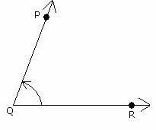
Angle PQR
Vertex - Q
Arms -QP,QR
Angles Measure in degree.

Types of angles
- Zero Angle:-
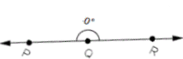
No angle between the two arms QP and QR is called zero degree angle.(two arms overlap)

2. Acute Angle:-
Angle between two arms is less then 90⁰ And greater then 0⁰ is called acute angle
0⁰ < < 90⁰
3. Right Angle:-
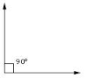
Angle between two arms is 90⁰ is called right angle.
4. obtuse Angle:-
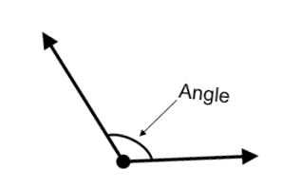
Angle between two arms is more then 90⁰ And less then 180⁰ is called obtuse angle.
90⁰ < < 180⁰
5. Stright Angle:-
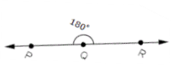
Angle between two arms is 180⁰ is called stright angle.
6. Reflex Angle:-
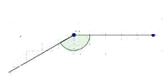
A Angle between two arms is greater than 180⁰ and less than 360⁰ is called reflex angle.
180⁰ < < 360⁰

7. Complete Angle:- A Angle is 360⁰ then its called complete angle.

^{(Right angle)}
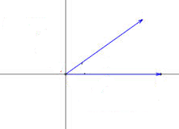
^{(Acute angle)}

^{Zero Angle}
^{(Vertex Angle)}

Pairs of angles:-
- ^{Adjecent Angle:-}
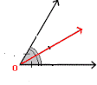
^{Two angles are Adjacent if}
^{(i) They have a common vertex}
^{(ii) They have a common arms}
(iii) The other two non-common arms lies on the opposite sides of the common arm.
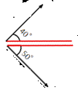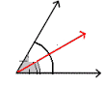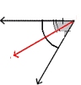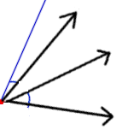

Linear Pair:- Two adjecent Angles form a linear pair if their non-common arms from a stright line and the sum of all angles are180
^{Vertically Opposite Angles:-}
Two Angles formed by two intersecting lines having no common arm but a common vertex are called opposite angles.
^{<1=<2}
^{<3=<4}
<1+<3=180⁰ ¹
<3+<2=180⁰ ³ ⁴
<2+<4=180⁰ ²
<4+<1=180⁰

<a=50⁰
<b=180⁰-50⁰=180⁰
<c=130⁰
Complementary angles:- Two angle whose sum in 900 is called Complementary angles.These angles adjecent as well as non-adjacent angles.
a+30⁰=90⁰
a=90⁰-30⁰
a=60⁰
Question:- Write the complement angle of 71⁰
^{ans: 90-71 = 19}
^{Supplimentory angles:-}
Two Angles whose sum of 180⁰ Are called supplementary angle.These angle are adjacent as well as non adjacent angles.
a+80⁰=180⁰
a=180⁰-80⁰
a=100⁰

Question:- write the Supplement angle of 93⁰
^{ans:-} 180⁰⁻ 93⁰⁼87⁰
Question:- How many degree are there in:-
(a)2/3 right angle $\frac{2}{3}$ x90⁰=60⁰
(b)5/6 stright angle $\frac{5}{6}$ x90⁰=75⁰
(c)2/15 complete angle $\frac{2}{15}$x360⁰=48⁰
Question:- kind of Angles:-
WN N ^{NE}

W E
^{SW} ^{ES} ^{S}

(a) North and south = straight angle
(b) North and North West = acute angle
(c) South and east = right angle
(d) East and West = straight angle
(e) East and North West = acute angle
(f) East and West south = Reflex angle
(g) East and south west = obtuse angle
(e)East and west north = Reflex angle

Chapter-11
Pairs of Lines and Transversal
Transversal:-A line which intersect two or more lines at different points is called transversal to the given lines.
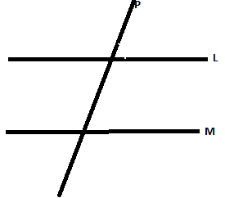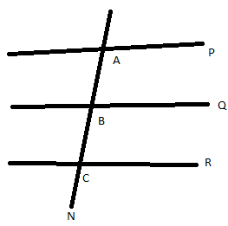
When a transversal intersect two line in a plane, eight angles are formed.
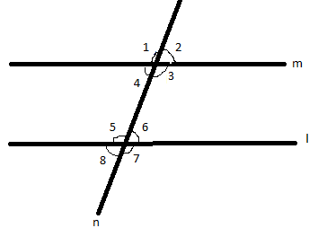

1. Interior angle:- <3,<4,<5,<6
2.Exterior angles:- <1,<2,<7,<8
3.Corresponding angles:- <1=<5
<2=<6
<4=<8
<3=<7

4. Alternate interior angle:- <3=<5
<4=<6
5. Alternate Exterior angles:- <2=<8
<1=<7

6. Linear Pairs:- <1+<2=180⁰
<2+<3=180⁰
<3+<4=180⁰
<1+<4=180⁰
<5+<6=180⁰
<6+<7=180⁰
<7+<8=180⁰
<5+<8=180⁰
7.Interior 0ppangles:- <3+<6=180⁰
<4+<5=180⁰
8.Vertically opp.angles:- <1=<3
<2=<4
<5=<7
<8=<6
Question:-Find all the angles

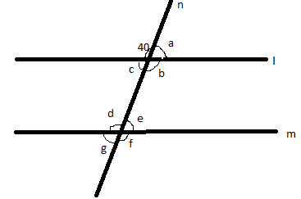
<b=40⁰ V.O.A
<b=<d=40⁰ Interior opp.angle
<d=<f=40⁰ V.O.A
a +40⁰=180⁰
a +40⁰-40⁰=180⁰-40⁰
a=140⁰
<c=<a=140⁰ V.O.A
<c=<e=140⁰ Interior opp.angle
<e=<g=140⁰ V.O.A

Chapter 12
Triangle
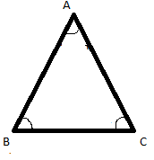
A closed three sides figure is called Triangle.
- There are three sides AB,BC,CA
- There are three angles
(i)<BAC,<CAB
(ii)<ABC,<CBA
(iii)<ACB,<BCA
- There are three vertex A,B,C
A triangle has three sides,three vertexes and three angles
TYPES OF TRIANGLE:-
We can classified the triangle on two basis:-
- On the basis of sides
- On the basis of angle

(i)On the basis of sides:-
- Scalene:-All the three sides are different in length is called scalene triangle.
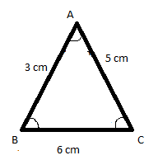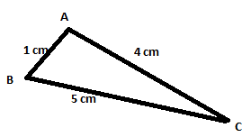
AB≠AC≠BC AB≠AC≠BC

- Isosceles:-Any two of the sides are same in length is called isosceles.
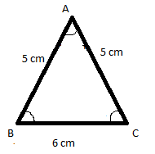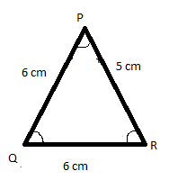
AB=AC≠BC PQ=QR≠PR

(C) Equilatered:-All three sides are same in length is called equilateral.
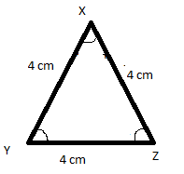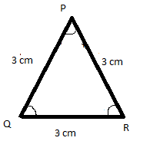
AB=AC=BC PQ=QR=PR

- On the basis of angle:-There are three types of triangle on the basis of angles.
Acute angled triangle:-If a triangle contain all three angles less then 90⁰ is called acute angled triangle.

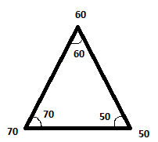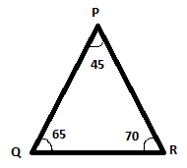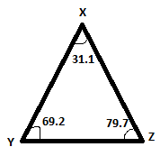
60⁰+70⁰+50⁰=180⁰ 45⁰+65⁰+70⁰=180⁰ 31.1⁰+69.2⁰+79.7⁰=180⁰
Right angle triangle:-If a triangle contain one angle in 90⁰ and rest two are acute is called Right angled triangle.

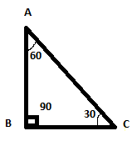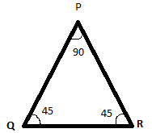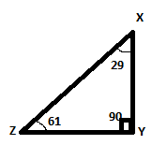
Important:-we can’t construct two right angle in a single triangle because the sum of three angle must be 180⁰ in a triangle but two right angle will be 90⁰+90⁰=180⁰ and one angle 90⁰+90⁰ +a=180⁰+a(More than 180⁰)
Obtuse angled triangle:-if a triangle contain one angle more then 90⁰ and rest two are acute is called obtuse angled triangle.
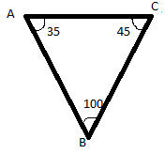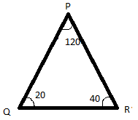

Important:- (i)we can’t construct two obtuse angle in a triangle because the sum of two angle will be more then 180⁰ and the third angle has left.
More than 90⁰+ more than90⁰+a=more than 180⁰+a
(ii ) we can’t construct triangle with obtuse angle and right angle because the sum will be more then 180⁰
More than 90⁰+90⁰+a =more than180⁰+a
CONSTRUCTION OF TRIANGLE:-
There are two types:-
- On the basis of sides
- On the basis of angle
(i)On the basis of angles:-the sum of all the three angles in 180⁰
(a)Scalene triangle :-all angle are different so, all sides are also different.
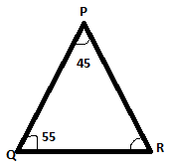45⁰+55⁰=100⁰+80⁰=180⁰
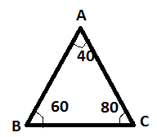
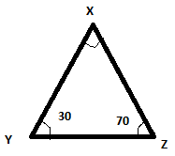
40⁰+60⁰+80⁰=180⁰ 180⁰-100⁰=80⁰

(b)isosceles Triangle:-two angles are equal so two sides are also equal
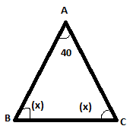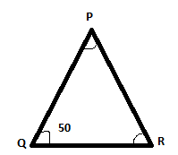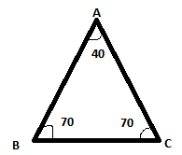

180⁰-40⁰=140⁰ ? ?
140⁰/2=70⁰
Angle x = Angle x =70⁰

(c)Eqvilaternal triangle:-All the sides are equal and all the angles are also equal .They must be 60⁰,60⁰,60⁰
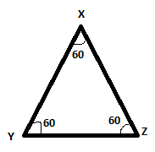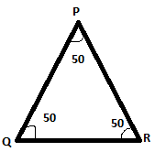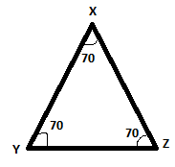

60⁰+60⁰+60⁰=180⁰ 50⁰+50⁰+50⁰=150⁰ 70⁰+70⁰+70⁰=210⁰
150⁰<180⁰ 210⁰>180⁰
(ii)On the basis of sides:-The sum of two sides of a triangle is greater than the third side.

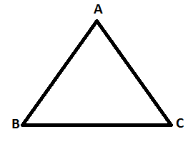 AB+BC>AC 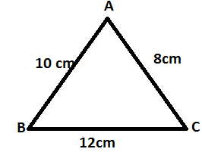10+12=22>8
AB+AC>BC 10+8=18>12
AC+BC>AB 12+8=20>10
If its not happened then we can’t Construct the triangle
(1)a=5cm b=10cm c=15cm 5+10=15=15
(2)a=10 b=8cm c=20cm 10+8=<18<20
So ,in above two condition we can’t construct the triangle.
Triangular Regians:-
The vertex and the points which are on the triangle and interior of the triangle is called Triangular region
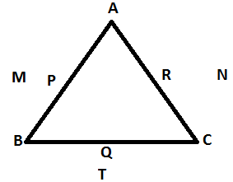
A,B,C,P,Q,R,X,Y,Z
M,N,T are exterior of the triangle is not in Triangular Region
Exterior angle of triangle:-
Interior angles:-<1,<2,<3
<1+<2+<3=180⁰
Exterior angles:-<4,<5,<6
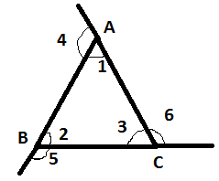
Exterior angle Interior opposite angles Interior adjecent angles
<4 <2,<3 <1
<5 <1,<3 <2
<6 <1,<2 <3
Important:-
- Every Exterior angle is equal to sum of interior opp. Angles.
<4=<2+<3 <5=<1+<3 <6=<1+<2

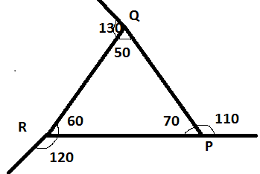 130⁰=60⁰+70⁰=130⁰
120⁰=50⁰+70⁰=120⁰
110⁰=50⁰+60⁰=110⁰
- The sum of every Exterior and interior adjacent angle is 180 ⁰
130⁰+50⁰=180⁰ 120⁰+60⁰=180⁰ 70⁰+110⁰=180
- Sum of all three exterior angle are always 360⁰
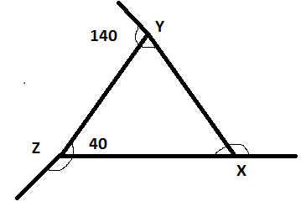 130⁰+120⁰+110⁰=360⁰

P

Q R
Side opp. to vertex P is QR
Side opp. to vertex Q is PR
Side opp. to vertex R is PQ
Vertex opp. to side QR is P
Vertex opp. to side PR is Q
Vertex opp. to side PQ is R

Question:-in the figure ,name the triangle which have
A

D

B F C

A as one vertex
ΔAEC, ΔAED,-----------
- B as one vertex
ΔBPD,ΔBAP,-----------
- E as one vertex
ΔEPC, ΔEDP,------
- DF as one side
ΔDFE, ΔDFC------
- BC as one side
ΔBCD,------
- AE as one side
ΔAEC,--------

CHAPTER -13
CIRCLE
C
G
F
E
B
A

H
D
A round plane Figure is called Circle.
- o is the center of circle .
- Radius:-Radius is the line segment joining the center of the circle to any point on the circle i.e. OA,OB,OC,OD.we can draw infinite numbered radii in a circle ,and all the radii are equal.
- Diameter:-A line Passing through the Centre of the circle and touches end points on the circle i.e AB,CD. we can draw infinite number of Diameter in a given circle.
Important:-AB=OA+OB
AB=OA+OA
AB=2OA
Diameter=2xradious
So, radious=Diameter/2
- Chord:- A chord is a line segment whose end points lie on the circle but not passing through the center of the circle i.e EF,GH
Important:- Diameter is the longest chord of a circle.

- Arc:-A small part of circle is called arc
R
Q
B
A
P
C

Circumference of a circle: - Parameter of a circle is called circumference of a circle i.e. boundary of a circle is called circumference.

Semicircle: - A diameter divides circle in two half parts and these parts are called semicircle.

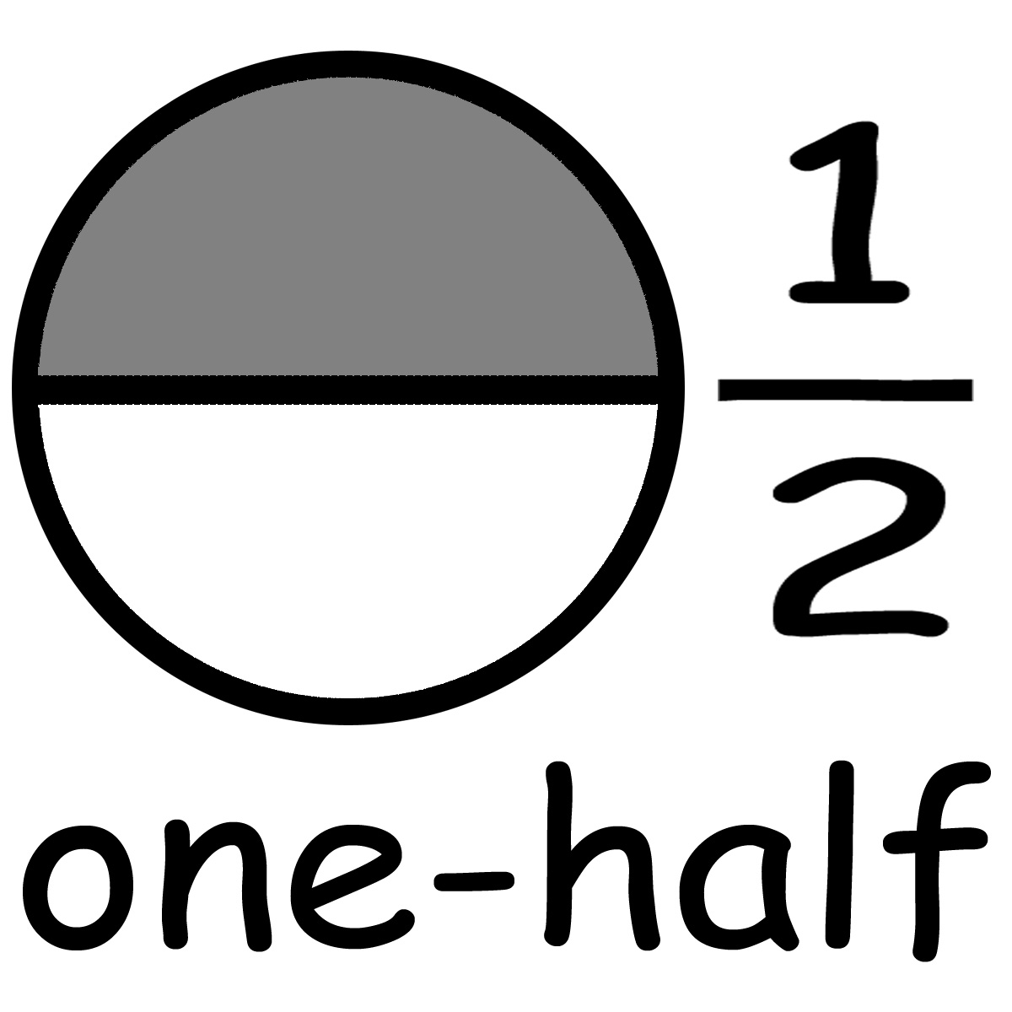

Quarter: - Two diameter divides the circle in four parts and these parts are called quarter.
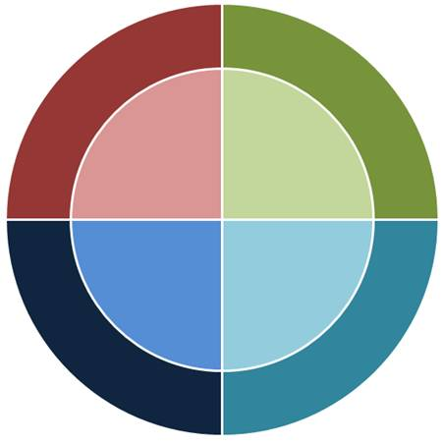
Important:- If radius in 8cm then diameter is 16cm

If diameter is 12cm then radius is 6cm

Q. Look at the circle carefully and answer the question.
C
A
O
B
X
G
F
E
D

(a) Name of two diameters –BG, CD
(b) How many chords are there – 4 (BC, CG, DG, BD)
(c) Name of all radius - OB, OC, OD, OG
(d) Name of two arcs – BAC, DEG
(e) Name semicircles – BAG, CAD, BEG, CED
(f) Is FO is a radius – NO
(g) Is CX is a chord – NO.

Chapter -15
PERIMETER & AREA
Perimeter – The length of the boundary of a figure .

A
C

B

P = a + b + c
a

a
b
b
Rectangle

P = a + b + a + b
P=2a+2b
P=2(a+b)
a
a
Square
a

P = a + a +a + a

P = 4a

c
B
A
d
b
F
C

e
a
f
E
D

P = a + b + c + d + e + f

a
B
A

b
d
e

c
D
C

P = a + b + c + d
(e is not in perimeter)

Area – The region covered by the perimeter is called area.
L
L x B
B
B

L

Perimeter of rectangle = 2(L+B)

Perimeter of square = 4x side
a

a x a
a
a
a

Area of rectangle = LxB
Area of square = side x side
Q. Find perimeter and area of rectangle whose length is 12 cm. and breadth is 10 cm.
Ans. P of rectangle = 2(L + B)
= 2(12 + 10)
= 2 x 22
= 44 cm.
Area of rectangle = Lx B
= 12 x 10
= 120 cm.²
Q. Find the perimeter and area of square whose side is 9 cm.
Ans. P of square = 4 x side
= 4x9
= 36 cm.

Area of square = sidexside
= 9 x 9
= 81 cm²
Area of rectangle = L x B
L = Area / B
B = Area / L

Q. If area of rectangle is 1000 cm². If the length is 100 cm. then what is the breadth?
Ans. B = Area / L
= 1000 cm² / 100 cm
= 10 cm.
Area of Square = side x side
Side = Square root of area of square

Q. Perimeter of a square lawn is 72 cm. then find its area.
Ans. P of square = 72 cm.
Side = 72 / 4
= 18 cm.

Area of square = sidexside
= 18 x 18
= 324 cm²

Important: -
Q. What will happen to the area of square when
(a) Its side is doubled ?
(b) Its side is half ?

2x
2x
x
1
x
x
2
2x

Area 1 = side x side
= Xx X= X² cm²
Area 2 = side x side
= 2x x 2x = 4x² cm²
Area 2 = 4 x Area 1
Area 2 = 4 times of area 1

(b)
x/2
x

x
x/2
x/2
x
1
2
x/2
x

Area 1 = side x side
= x * x = x² cm²

Area 2 = side x side
= x/2 * x/2 = (x² cm²)/4
Area 2 = ¼ x Area 1
Area 2 = 1/4 times of area 1

