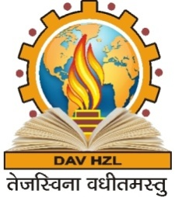
DAV HZL SENIOR SECONDARY SCHOOL
RAJPURA-DARIBA, RAJSAMAND (RAJ.) 313211
CBSE Affiliation. No. 1730592
(Managed By: DAV College Managing Committee, New Delhi)
Session 2015-16
Schedule for Summative Assessment –II
Class-IX & X
Date | Day | Class IX | Class X
11.03.2016 | Friday | Social Science | Mathematics
14.03.2016 | Monday | Mathematics | Social Science
16.03.2016 | Wednesday | Hindi | Hindi
19.03.2016 | Saturday | English | Science
22.03.2016 | Tuesday | Science | English

Note:
1. Concerned students will have their preparatory leave on 10.03.15 for class IX & X.
2. School time during the examination days for the concerned students will be from
8.30 a.m. to 12.00 noon.
3. There will be no teaching during examination days.
4. Students should clear all their school dues to get the examination admit cards.

(D.Sen Sharma)
Principal

